Punctuality Challenge

The challenge was set for children to arrive on time to school every day from
7th February - 18th February 2022.

We had an amazing total of 542 children who arrived to school on time. Well done to each of these children.

All of them will be provided with a wristband in the colour of their class.

All of the 542 children were put into a draw for a special prize for each year group.

The winners are as follows …………….

6 Yellow
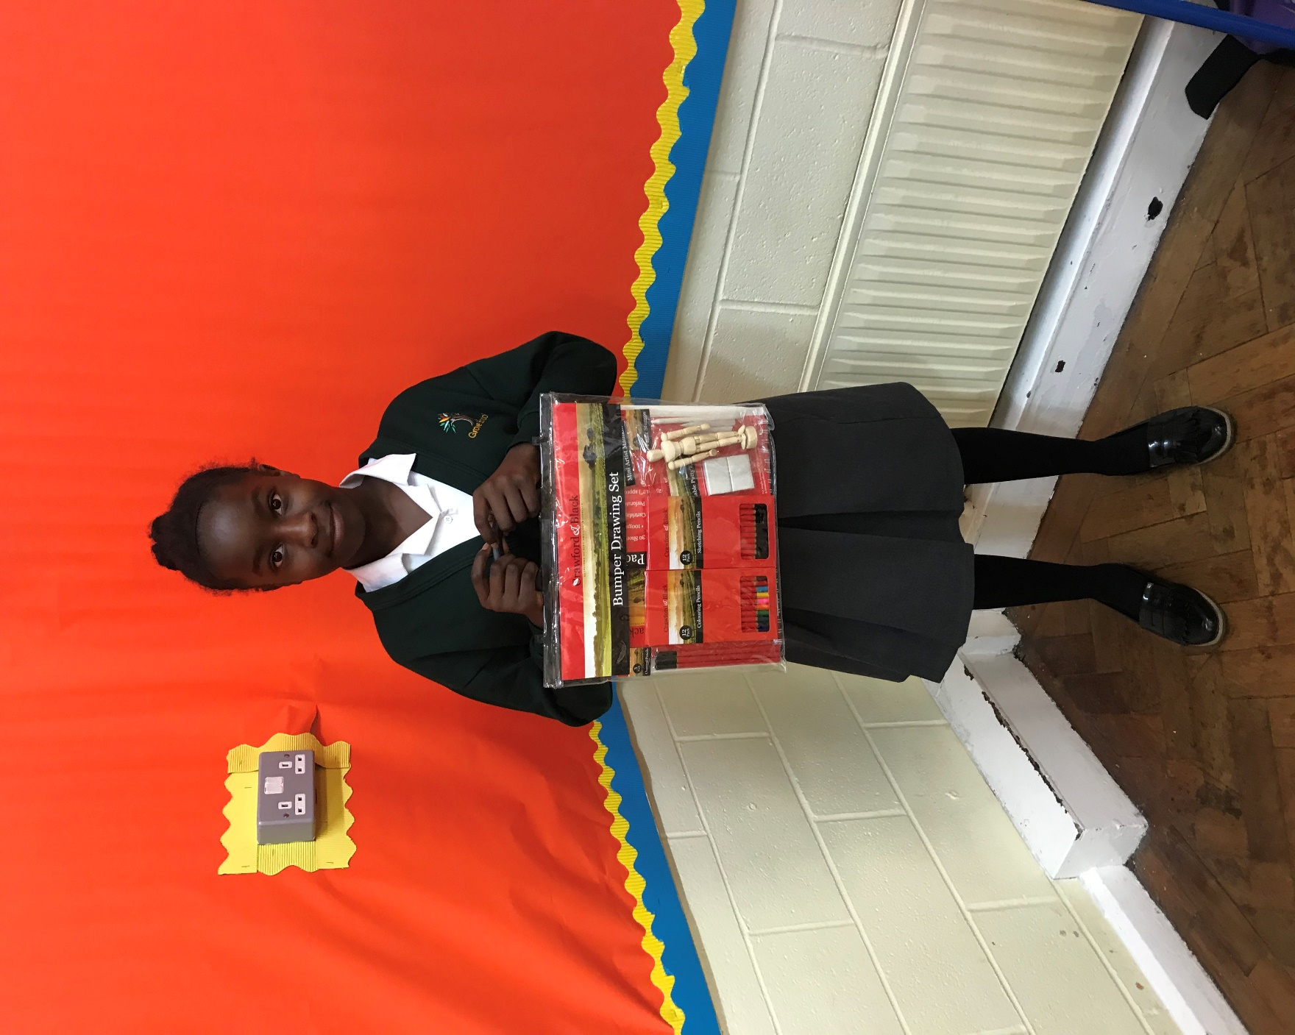
Jaxsen-Rae

5 Red
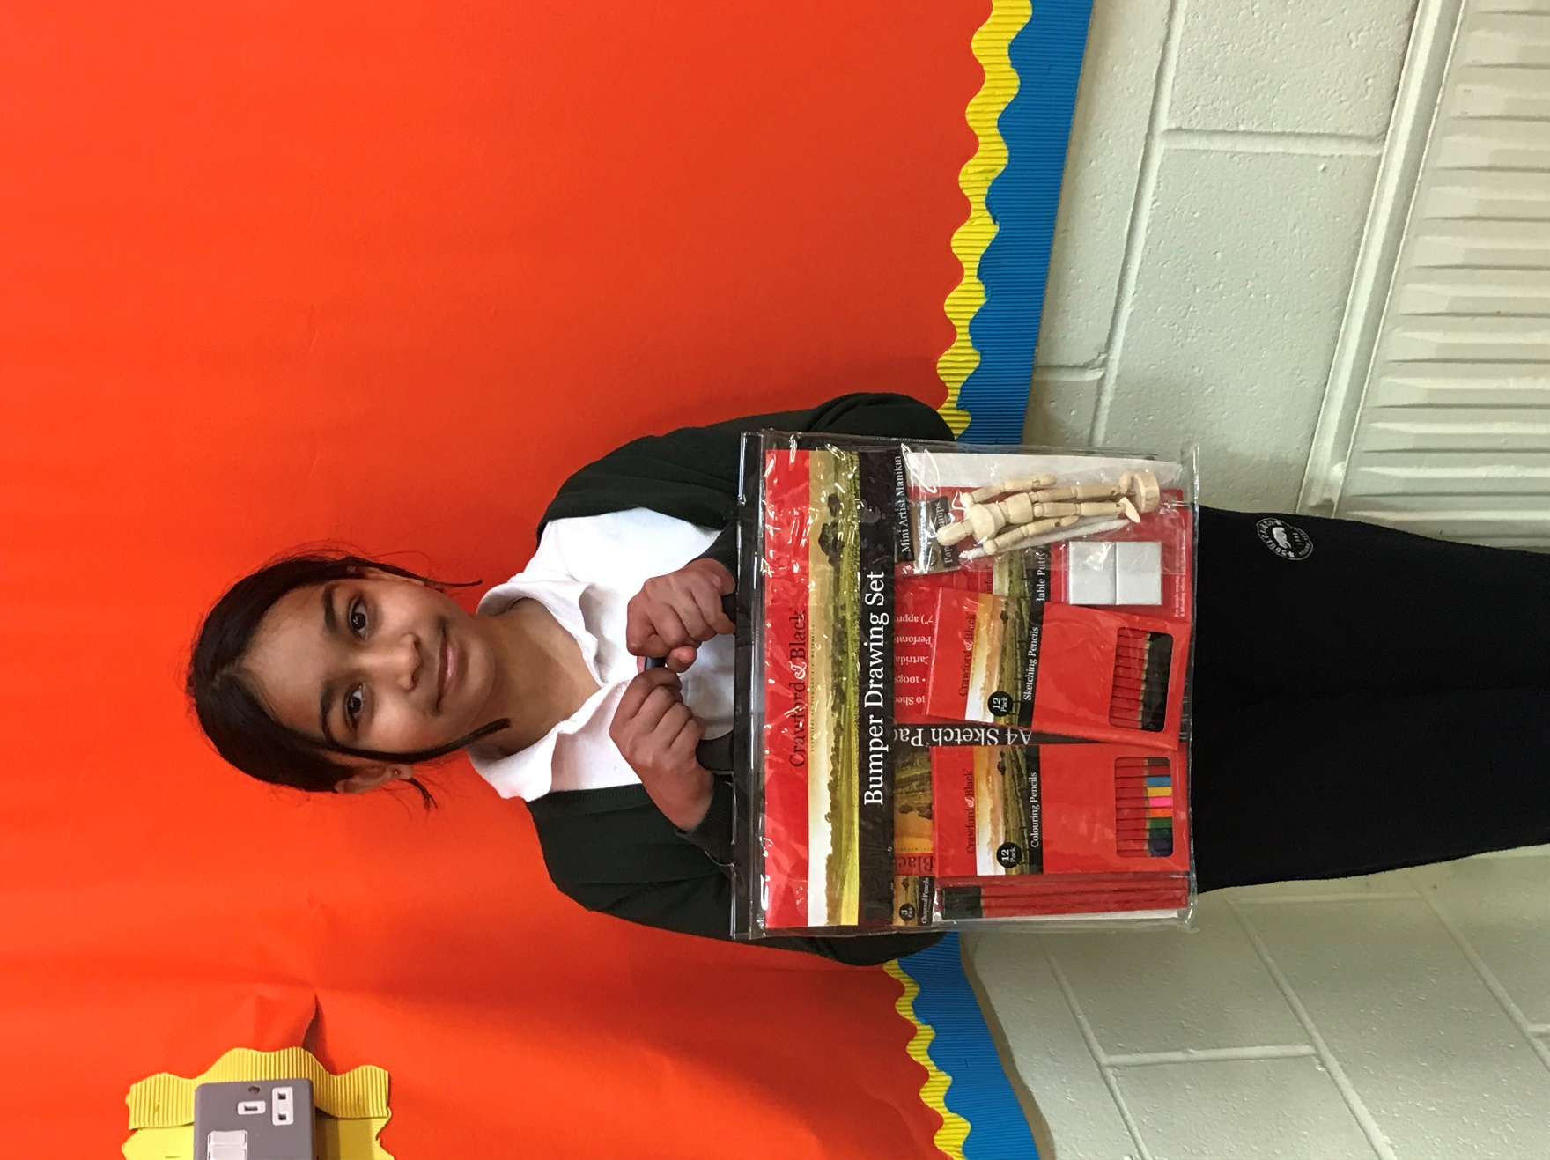
Roshni

4 Yellow
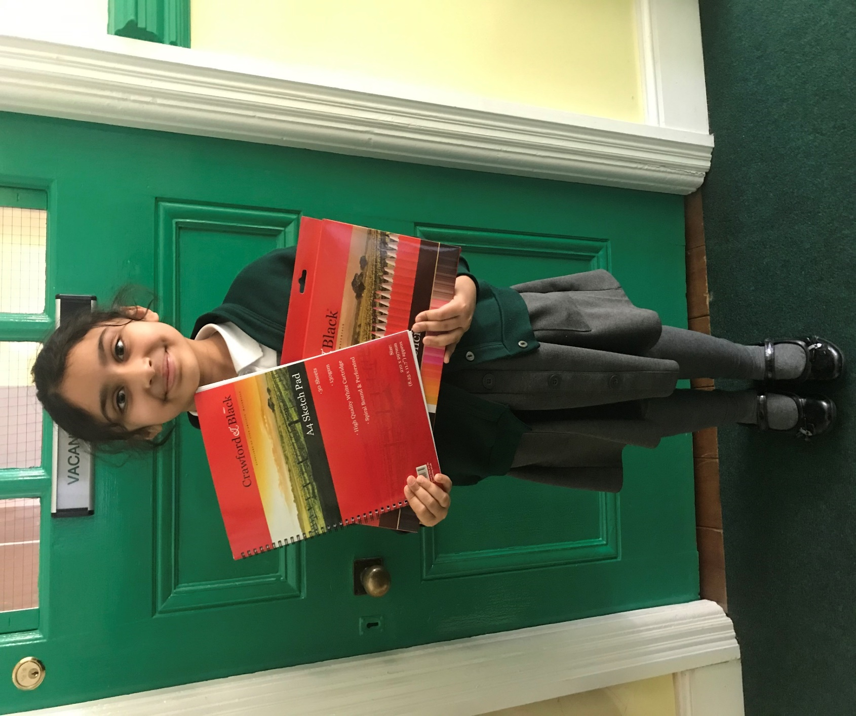
Menaal

3 Red

Haleema

Year 2

To be announced

Year 1

To be announced

Reception Green
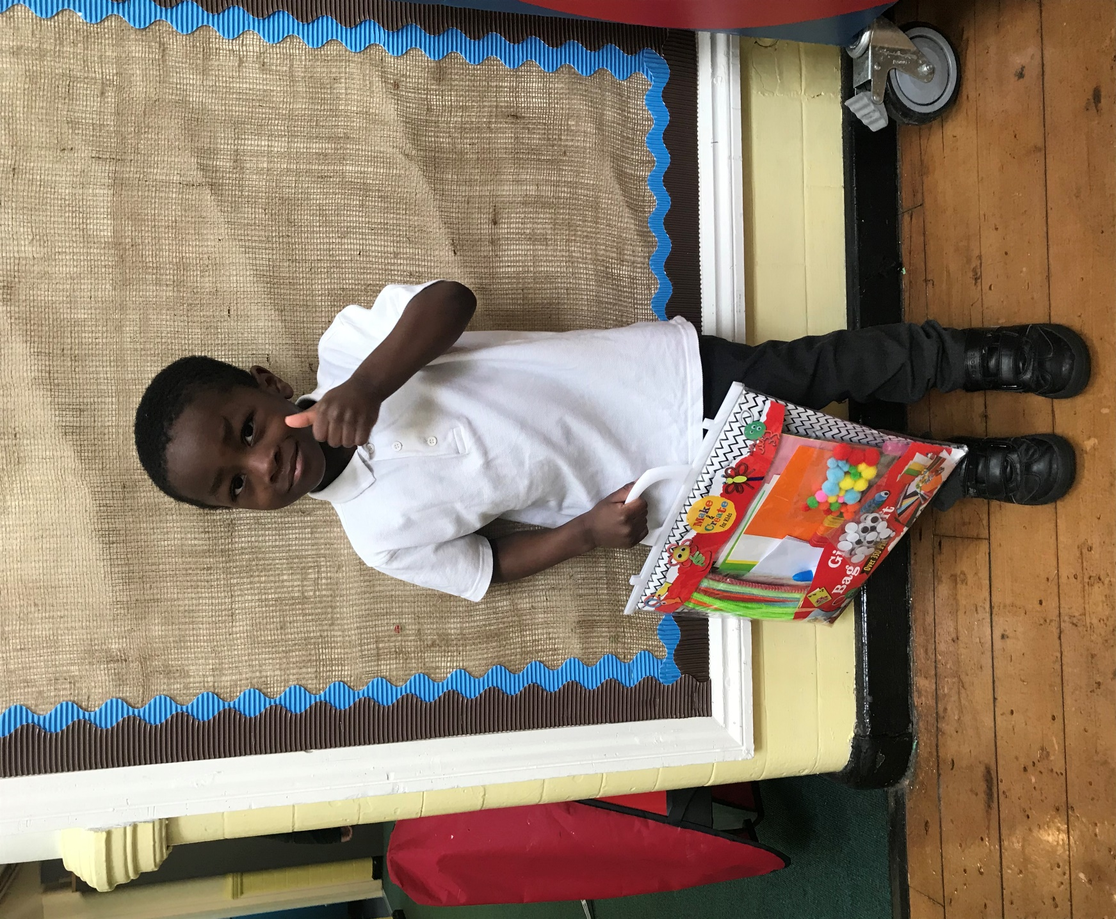
Akhbar

Nursery Yellow

To be announced

