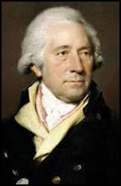
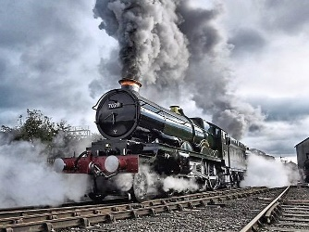
Year 6 Holiday Project
December 2021

Full steam ahead
Next half term, our topic is the History of Handsworth. We will be learning all about two very important men: James Watt and Matthew Boulton.

Your task is to research these two men and why they are so important to our local history.

You may want to think about:
- The time period they lived in;
- How the two men met;
- The invention of the steam engine and its importance to society;
- Their connection to Soho House;
- Why they are still remembered today.

You can choose how you present your research. This might be in the form of a poster, a power point presentation or you could use BGFL.

Please return your holiday project to your teacher on Tuesday 4th January 2022.

