**Year 5 to Year 6 Holiday Project 2025**

*When you return to school, you will be learning about World War 2. For your holiday project, we would like you to complete one of the challenges below:*

1. **Create your own Anderson Shelter**

During the war, people were encouraged to build an Anderson Shelter in their garden. They were made out of corrugated iron sheets with earth piled on top. They looked a bit like this:

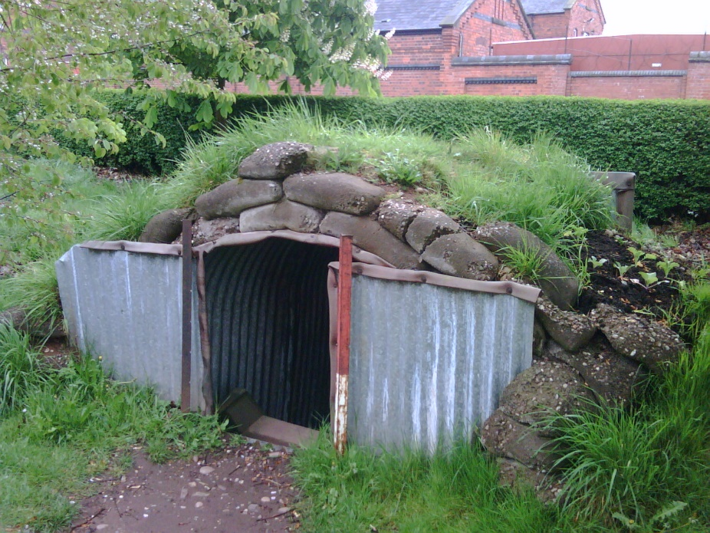

If your home was at risk of being bombed, you and your family could shelter inside, sometimes for many hours.

We would like you to make your own shelter at home to bring into school to put on display. During the war, there was a big focus on ‘make do and mend’ which is based around reusing things rather than throwing them away. So rather than buying lots of items to make your shelter, why not use an old cereal box and some colouring pens? You could even collect some leaves from your garden to put on the top of your shelter to make it less visible to German bombers!

1. **Research what it was like for children during World War 2 and create a poster**

Create a poster about what it was like for children during the war to put on display at school. You might like to look at:

* Evacuation
* Rationing
* School life
* Air raids

Some helpful websites for your research are:

* <https://www.bbc.co.uk/teach/class-clips-video/articles/zjnyscw>
* <https://school-learningzone.co.uk/key_stage_two/ks2_history/british_history_/world_war_ii/world_war_ii.html>
* <https://www.primaryhomeworkhelp.co.uk/war/children.htm>

You might also wish to visit Handsworth Library to find a book about World War 2.

*We look forward to seeing your projects when you return to school Wednesday 3rd September 2025.*