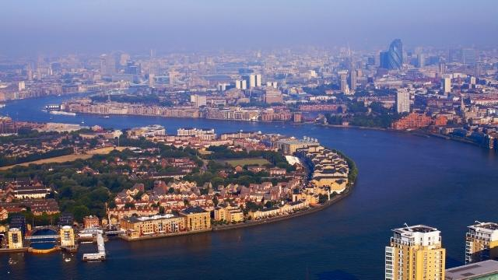
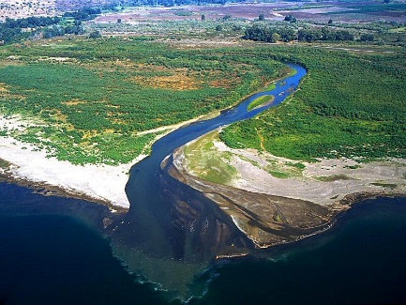
Year 6 Holiday Project
March 2024
Rivers

Next half term, our topic is rivers. We will be learning all about the River Thames in London including locating this on a map and looking at where the river flows through.

Your task is to research a different river. This does not have to be a river in the UK; it could be anywhere in the world!
You may want to think about:
- Where the river begins
- Identifying the river on a world map
- People that use the river
- Any key features of the river
- Wildlife in or around the river
You can choose how you present your research. This might be in the form of a poster, a power point presentation or you could use Bgfl.
If you use the internet to research about rivers, remember to do a safe search and tell an adult.

Please return your holiday project to your teacher on Monday 8th April 2024.

