Year 6
Holiday Project - Autumn 2

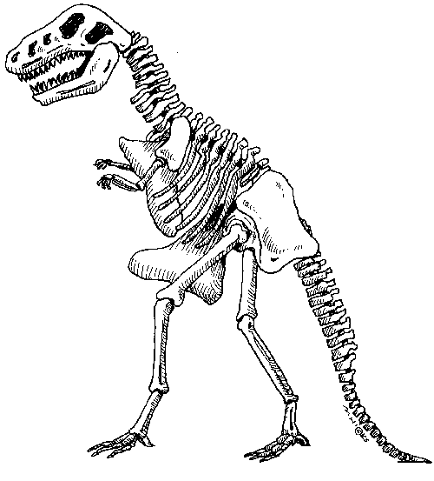
Imagine you have just discovered some bones or fossils in your garden. These could belong to any animal that lived in the past. Perhaps they belong to a dinosaur or a mammoth, or even an animal that hasn’t been discovered yet! The Natural History Museum would like you to tell them what you discovered, what it looked like and about the creature you think they might have come from.

You can choose how to present your work: as a model, as pictures or as a descriptive piece of writing. Why not look at the Natural History Museum website (https://www.nhm.ac.uk/) to find out more about fossils and dinosaurs?

We will be learning more about fossils and evolution in our science topic next term!

If you use the internet, remember to do a safe search and tell an adult.

Please return your project on Monday 3rd November.

