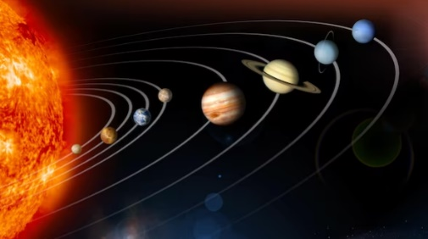
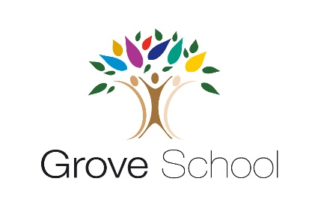

Year 5 Holiday Project
March 2024

In year 5, we will be learning about the Earth and beyond in science.

We would you to research the different planets in our solar system and their different features.

You can choose what you want to create. For example, a piece of artwork, a model, a factual poster or a presentation.
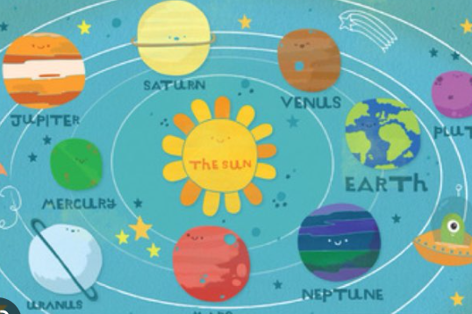
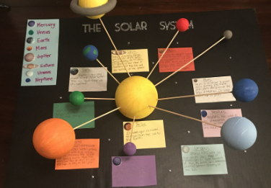

Be as creative as possible, we want to fill our classrooms with your beautiful work!
