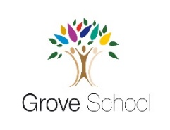
Year 4 holiday project
May 2024
Vertebrates and Invertebrates

We will be learning about vertebrates and invertebrates in science. We would like you to create a fact file all about your favourite animal or insect.
Your fact file should include:
- What type of creature it is,
- Some key characteristics of the creature, such as the number of legs, its colour, its skin (is it scaly? furry? feathered? etc.),
- Its habitat,
- Its diet.
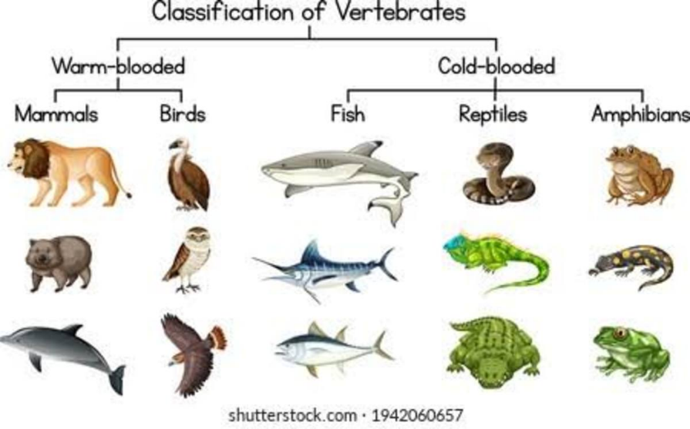

Please return your project to you class teacher on Monday 3rd June 2024.

