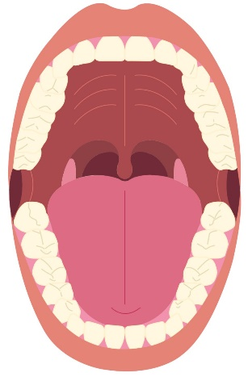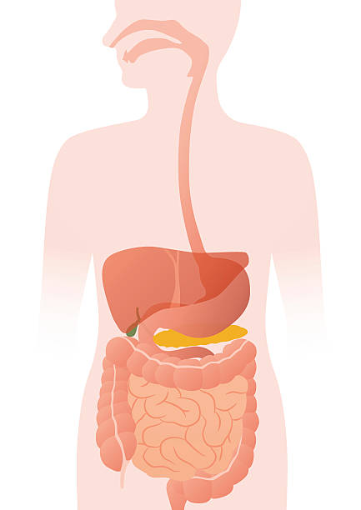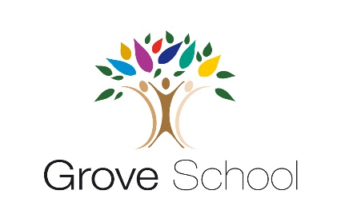

Year 3 to Year 4 Holiday

Project

Summer 2025

In year 4, we will be learning about the digestive system in science.

We would like you to research the different teeth we have and their purposes.

You can choose what you want to create. For example, a piece of artwork, a model, a factual poster or a presentation. You can use these websites to help you.

<https://www.youtube.com/watch?v=aOebfGGcjVw>

<https://www.coolkidfacts.com/teeth-facts/>

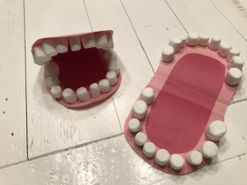Be as creative as possible, we want to fill our classrooms with your beautiful work!