Year 2 to Year 3

Holiday Project Summer 2025

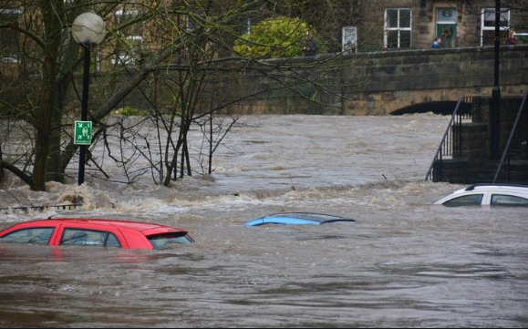**In Year 3, we are going to be learning about different climate zones around the world. This will include exploring the different kinds of weather such as a drought, flooding and heatwaves.**

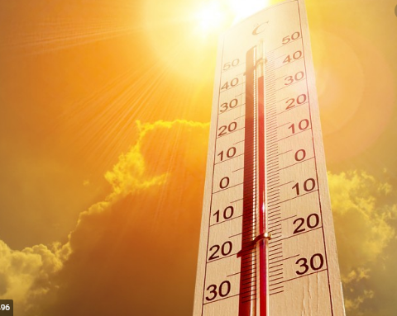

We would like you to choose one of these tasks:

* Create a weather diary of your local area. Think carefully about how you present your findings. This may be on a chart, a recording of you presenting the weather or an informative leaflet.
* Research one of the types of weather above; a drought, flooding or heatwaves and create a fact file or a piece of art to represent it.