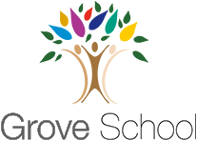

Year 2 Holiday

Project – Summer 1

Next half term, year 2 will be studying a cookery topic in Design and Technology.

Have a go at one of the project ideas below:

* Cook a meal with a member of your family and take pictures. Can you put these pictures into the correct order?
* Design your favourite meal as a poster. Label all of the foods and describe why they are good for you.
* Make your own mini cookbook with your favourite recipes in.
* With your family complete a blind taste test to see if you know which foods are sweet, sour, spicy and bland. Write down your results in a table.
* Research meals from around the world. What dish would you like to try? Present this in a poster.

