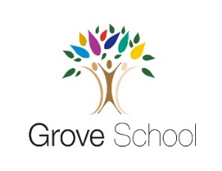

Year 2
Holiday Project
December 2021

Next half term in history we will be learning about ‘The Cadbury Brothers of Birmingham’.

We will be learning all about who the Cadbury brothers were and what they did.

Over the Christmas holidays, we would like you to research how the Cadbury brothers changed how people in 1878 lived their lives.

Think about:
- What were the working conditions like?
- What were the benefits of working for the Cadbury brothers?
- How do you think the workers felt about the changes the brother made to Bournville?

You can present your work as a poster on paper or on Jit5. You will need this research to use in our history sessions.

Please return your research to your teacher on Monday 4th January 2022.

