Year 2 holiday project
May 2024

The seaside

Our topic for the next half term is ‘Oh we do like to be beside the seaside!’

This is a very exciting topic all about the seaside. We will be visiting Weston-Super-Mare.

You have a choice of tasks. You can:

- Research Weston-Super-Mare and make a poster or fact file,
- Design an outfit that would be suitable for a sunny day at the beach (think carefully about what you would need to take with you),
- Design and write a postcard to one of your friends or teachers about your holiday,
- Write a set of instructions for a game you could play on the beach.
You don’t need to do all of them, just pick your favourite. Be creative and enjoy!

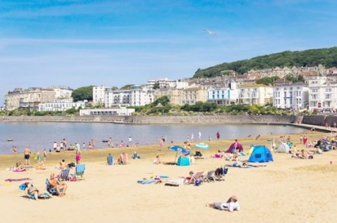
Please return your holiday project to your teacher on Monday 3rd June

