Year 2 Holiday Project
Autumn 2
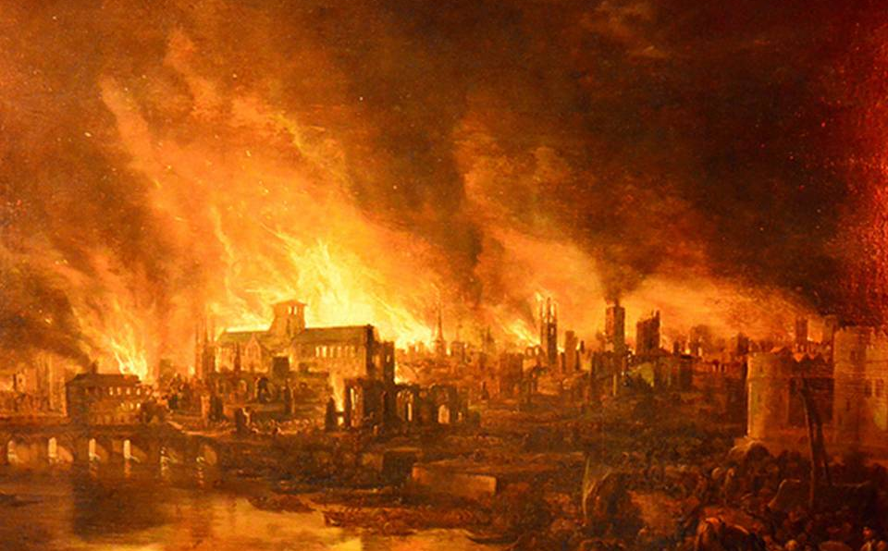
The Great Fire of London
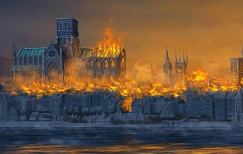

Next half term we will be learning about the Great Fire of London. Can you research what happened and then use the words below to help you write an acrostic poem about the events? You can do it on the back of this sheet or design your own.

Great Fire London

Pudding Lane disaster water 1666

escape River Thames bakery oven

put out spark sleeping panic scar

Great flames all over London
Really scary
Everyone escaping
All the people screaming
Thomas Farriner started it all!

F__________________________________________________
I __________________________________________________
R __________________________________________________
E __________________________________________________

O __________________________________________________
F __________________________________________________

L __________________________________________________
O __________________________________________________
N __________________________________________________
D __________________________________________________
O __________________________________________________
N__________________________________________________

