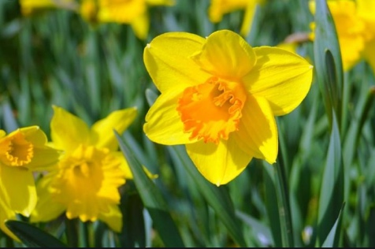

Year 1 Holiday Project
Spring 2021
Our topic for the next half term is Plant Detectives!
It is a very exciting topic all about how to grow plants and how to keep plants healthy.
For this holiday project you have a choice of what you can do.
Your options are:
- Write a set of instructions for how to grow a plant.

- Plant your own seed at home and watch it grow. Keep a diary of what changes throughout the holidays.

- Go on a plant hunt in your local park. Take pictures and draw all the different plants you can see.

- Look out for daffodils, tulips and bluebells.
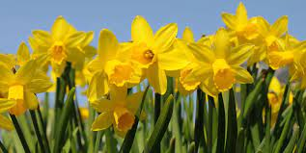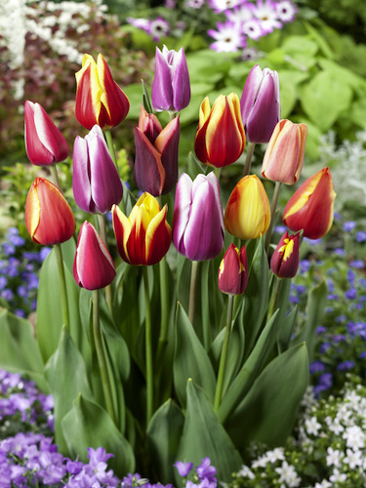
Tulips
Daffodils

Please return your work on Monday 19th April 2021

