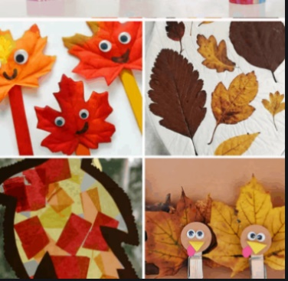
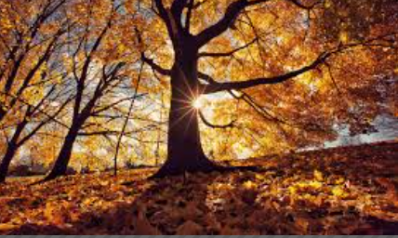
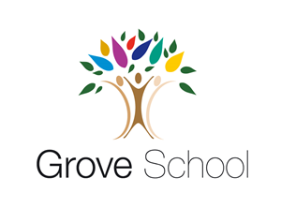

Year 1 Holiday Project
Autumn 2 2025

Autumn half term 2018

When we return to school we will be starting our science topic on Sensing Seasons. Look outside and describe what you notice is changing.
What colour are the leaves on the trees?
Were they always this colour?
What is the weather like?
What clothes are you wearing?
What animals can you see?
How is autumn different to summer?
What are the similarities and differences between autumn and summer?

Draw a picture of what you can see and label this.

