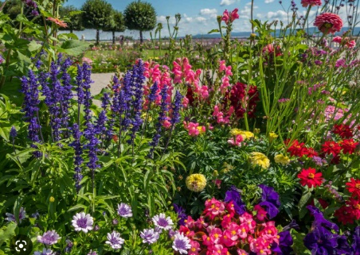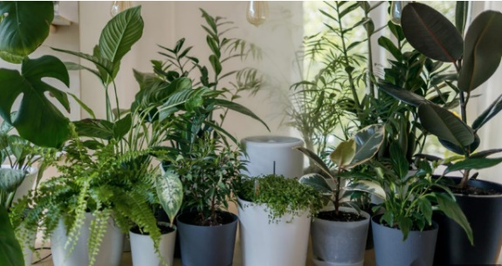

**Year 1 Holiday Project**

**March 2023**

**Autumn half term 2018**

When we return to school, we will be becoming Plant Detectives!

During the half term break, have a lookout for different plants. Name, draw and write a description of a plant below.

 _________________________________________________________

_________________________________________________________

_________________________________________________________

 _________________________________________________________