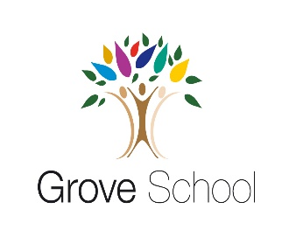

**Year 1**

**Holiday Project December 2021**

Next half term we will be exploring materials in our world.

We will be thinking about materials that keep us warm and dry, materials that are strong and weak and materials that are smooth or rough.

For the children’s holiday project, we would like them to make a boat. They will need to think carefully about how they can make their boat waterproof and if they can make it float. The children can use junk box materials.

We will test the boats in our outdoor learning area in January!

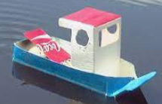 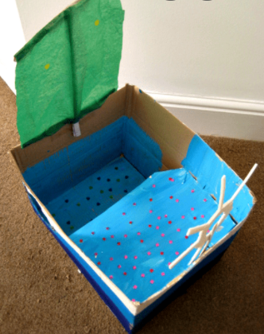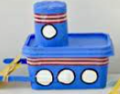

Please return your holiday project on

Tuesday 4thJanuary 2022