Design and Technology – Year 5
Spring 2 – Design, make and evaluate a homemade tomato sauce and homemade gnocchi
In Design & Technology I have already learnt:

To cut, slice, chop, peel and grate ingredients safely.
To sauté vegetables to soften them
To simmer a liquid to thicken it
To mix, knead, dust, rub and bind a dough mixture.

Design, make, evaluate, user, purpose, ideas, design criteria, product, Knife, slice, peel, cut, spread, chop, healthy diet, choosing, ingredients, planning, investigating, tasting, arranging, mixing, kneading, rolling, pushing, folding, proving, weigh, measure, scales, claw and bridge technique, rub, bind, roll, dough, rise, dust, cool, fry, blend, simmer, sauté

I can combine mashed potato, egg and flour into a dough.

I can roll and gently stretch the gnocchi dough.

I can use the boiling method to cook the gnocchi until they are soft and light.

I have refined my use of the bridge and claw safe cutting methods to prepare the vegetables for the tomato sauce.

New Design & Technology words:
Boil, mash, dice, gnocchi, sofficí e leggeri (soft and light), aldente. vocabulary of ingredients

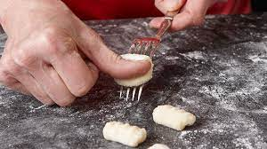
Rolling gnocchi to create the concave shape

