Design and Technology – Year 4
Spring 2 – Design, make and evaluate a pizza with a wholemeal base and a side salad
In Design & Technology I have already learnt:

To peel, slice, chop, cut, and grate ingredients safely.
To knead, rub, bind, roll, and pull dough to make bread products.
To fry vegetables using a heat source.
To simmer liquids to make them thicker

Design, make, evaluate, user, purpose, ideas, design criteria, product, knife, slice, peel, cut, spread, chop, healthy diet, choosing, ingredients, planning, investigating, tasting, arranging, mixing, kneading, rolling, pushing, folding, proving, weigh, measure, scales, claw and bridge technique, rub, bind, roll, dough, rise, dust, cool, fry, blend, simmer

I can sauté vegetables to soften them prior to adding them to the pizza.

I will strengthen my skills of mixing and kneading to make pizza dough.

I can stretch and press the dough to form the pizza base.

New Design & Technology words:
Sautee, sticky, tacky, stretch, press, vocabulary of ingredients

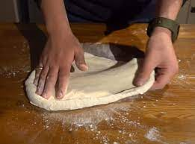
How to stretch pizza dough correctly

