Design and Technology – Year 3
Spring 1 – Design, make and evaluate a greetings card with moving parts
In Design & Technology I have already learnt:

That sliders and levers produce different types of movement.
How to make templates, measuring, marking and cutting out.
To join paper and card, using temporary fixing materials such as paper fasteners and permanent fixing materials such as tape and glue.
Design, make, evaluate, user, purpose, ideas, design criteria, product, template, mechanism, lever, slider, pivot, slot, guide or bridge, pull, push, up, down, straight, curve, backwards and forwards. card, masking tape, paper fastener, join

I will understand what a linkage mechanism is.

I will use lever and linkage mechanisms.

I can distinguish between fixed and loose pivots.

I know that the position of the pivot can be changed to alter the amount of movement.

New Design & Technology words:
Linkage, linear, oscillating, reciprocating, input, output, prototype

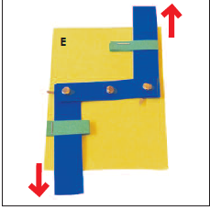
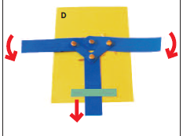
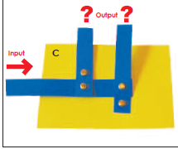
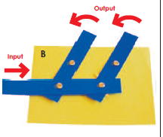
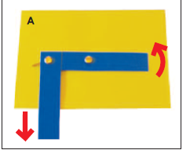
A variety of lever and linkage mechanisms

