Design and Technology – Year 2
Spring 2 – Design, make and evaluate a felt flower brooch
In Design & Technology I have already learnt:

I made my own templates, measuring, marking and cutting out.

To thread a needle .

To add finishing touches to make my product appealing to the user.

Design, make, evaluate, user, purpose, ideas, design criteria, product, function, join, thread, needle, finish.
I can join materials using running stitch.

I am strengthening my knowledge of joining materials using glue, stapling and pinning and can evaluate the advantages and disadvantages of each method.

I am extending my knowledge of finishing a product through use of textile paints, glitter, fabric crayons and sequins.

I can use a template or pattern and cut out the fabric piece for my product.

New Design & Technology words:
Template, pattern pieces, mark out, mock up, join, decorate, sew, running stitch, felt, finishing – textile paints – glitter and raised, sequins, fabric, fabric crayons

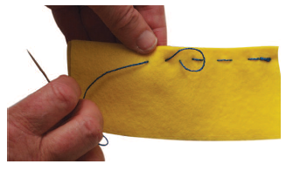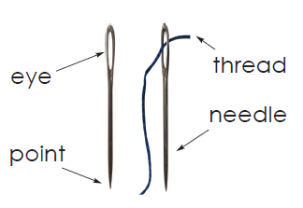
A simple running stitch
A labelled diagram of parts of a needle

