Design and Technology – Year 1
Spring 1 – Design, make and evaluate a strong chair for the class bear
In Design & Technology I have already learnt:

I made my own templates, measuring, marking and cutting out.
I joined paper and card, using temporary fixing materials such as paper fasteners and permanent fixing materials such as tape and glue.

I learnt to:

*Generate my own design ideas
*State the purpose of my design
*Select from a range of tools and equipment
*Use the correct technical vocabulary
*Make simple judgements about my product and suggest how it could be improved.
*Follow procedures for safety.

Design, make, evaluate, user, purpose, ideas, design criteria, product, function, Card, masking tape, paper fastener, join
I can talk about freestanding structures around school.

I can talk about their purpose, the material they are made from and how their parts have been joined together.

I can use construction kits to build walls and towers.

I can explore ways to make walls stronger by changing the brick pattern.

I can explore ways to make towers stronger by making the base wider, heavier or by adding buttresses.

I can fold paper and card to make freestanding structures.

I can join sheet materials and boxes together using different tapes and glue.

New Design & Technology words:
Cut, fold, fix, Framework, wall, base, joint, metal, wood, plastic, brick, triangle, square, rectangle, cube, cuboid, Structure, tower, framework, weak, strong, base, thinner, thicker, straight, curved

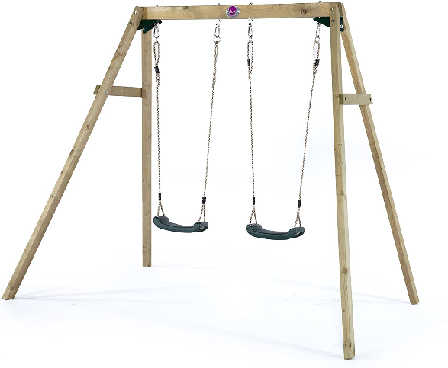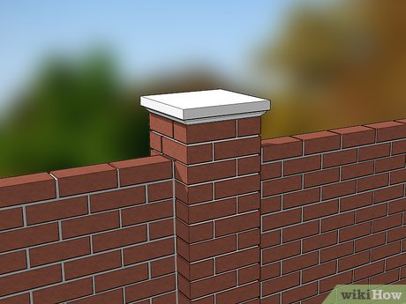
Free standing structures

