Reception to Year 1

Summer

Holiday Project

2025

In Year 1 in the autumn term, the children will be learning about toys from the past.

During the summer holiday please support your child in creating a fact file about toys from the past. Could you draw, label and write about a toy from the past?

[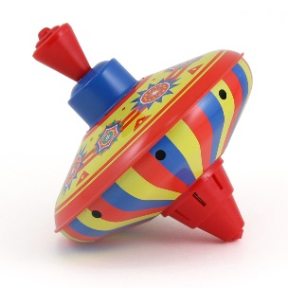](http://www.google.com/url?sa=i&rct=j&q=&esrc=s&frm=1&source=images&cd=&cad=rja&uact=8&ved=0ahUKEwihzJnwmYfOAhUqIcAKHRjaAm4QjRwIBw&url=http://www.retroplanet.com/PROD/26608.html&psig=AFQjCNGxp5_BNxwahPhcOJik4RXHgzAAfw&ust=1469281362393628)[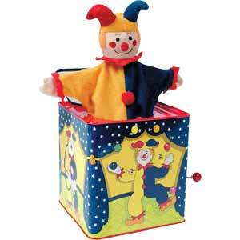](http://www.google.com/url?sa=i&rct=j&q=&esrc=s&frm=1&source=images&cd=&cad=rja&uact=8&ved=0ahUKEwjC6ImgmofOAhWIA8AKHXySC_AQjRwIBw&url=http://totrides.com/classic-old-fashioned-toys-1-year-olds/&psig=AFQjCNGxp5_BNxwahPhcOJik4RXHgzAAfw&ust=1469281362393628) [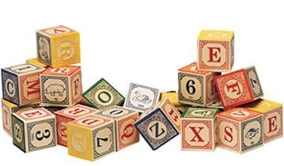](http://www.google.com/url?sa=i&rct=j&q=&esrc=s&frm=1&source=images&cd=&cad=rja&uact=8&ved=0ahUKEwj9ks-umofOAhWkKsAKHRSnAnMQjRwIBw&url=http://www.examiner.com/article/are-old-fashioned-toys-better&psig=AFQjCNGxp5_BNxwahPhcOJik4RXHgzAAfw&ust=1469281362393628)