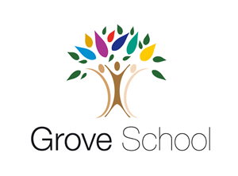
My name is _____________________
Reception holiday project May 2024
Pirates
Our exciting new learning for after the holiday will be ‘Pirates’. Your holiday challenge is to design and make a pirate ship for our pirates using cartons and containers you find around your home. Here are some examples to help you.
We will look forward to testing it in our water tray on Monday 3rd June, 2024
My pirate ship design

