Reception Holiday Project December 2021
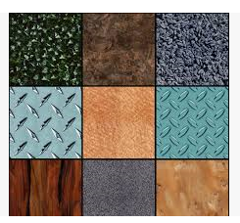
Next term Reception will be learning about materials in the world around us. We will collect and sort different materials. We will use words to describe the way they feel, such as hard, soft, shiny, rough and smooth.
Can you make a puppet using different materials?

For example, you could use some shiny kitchen foil, some soft cotton wool or some smooth paper.
Write sentences below, using your phonics skills.
What did you use?
_____________________________________________________________________________________
_____________________________________________________________________________________

What did they feel like?
__________________________________________________________________________________________________________________________________________

