
My name is _____________________
Reception Holiday Project Autumn 2
Autumn Treasure Hunt
Reception are learning all about autumn in the coming term. Go on a treasure hunt to the park and see if you can find autumn treasure.
Spot a squirrel. 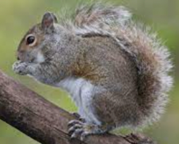
Find a stick man. 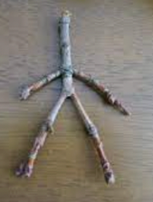
Collect five different coloured leaves. 
Collect a pinecone family. 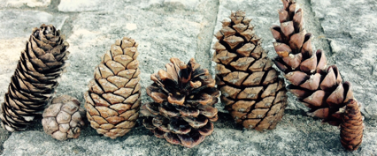
Find a shiny conker or an acorn. 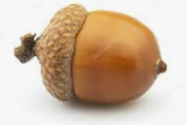 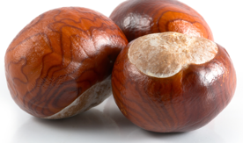

Find a feather. 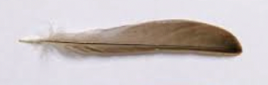
See a spider’s web. 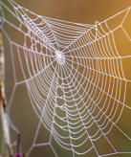

Please return your treasure hunt list and any of your treasure on Monday 3rd November, 2025

