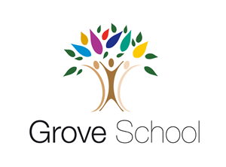
Nursery Holiday Project December 2021

Next term, Nursery will be reading lots of traditional tales. We will read the story of Hansel and Gretel, the Three little pigs, Goldilocks and the three bears, and many more. We would like the children to make a puppet of their favourite character from any of these stories.

You can use a sock, a spoon, a peg or cardboard to make the puppet. Don’t forget to put your name on it!

Please return your holiday project to your teacher on Tuesday 4th January 2022
