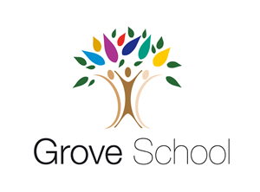
My name is _____________________
Nursery holiday project May 2024
Dinosaurs

Next term we learning all about dinosaurs.
Create your own 3D dinosaur using cardboard boxes and craft materials. Talk about the materials you are using with your family. Here are some examples.
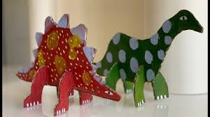
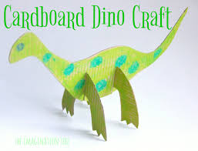

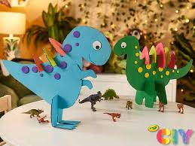
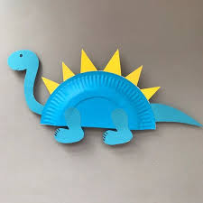

Please return your holiday project to your teacher om Monday3rd June / Wednesday 5th June 2024

