**Nursery Holiday Project Easter 2023**

Next half term we are learning about mini-beasts and farm animals.

For your holiday project we would like you to go on a mini-beast hunt around your garden, or around the park. How many mini-beasts will you find?

What did you see?

spider

ladybird 

worm 

butterfly 

beetle 

caterpillar 

centipede 

woodlouse 

Draw your favourite minibeast

Turn over to see information about visiting a farm.

If you can, why not visit Oak Tree Children’s Farm. Here is the information and prices.

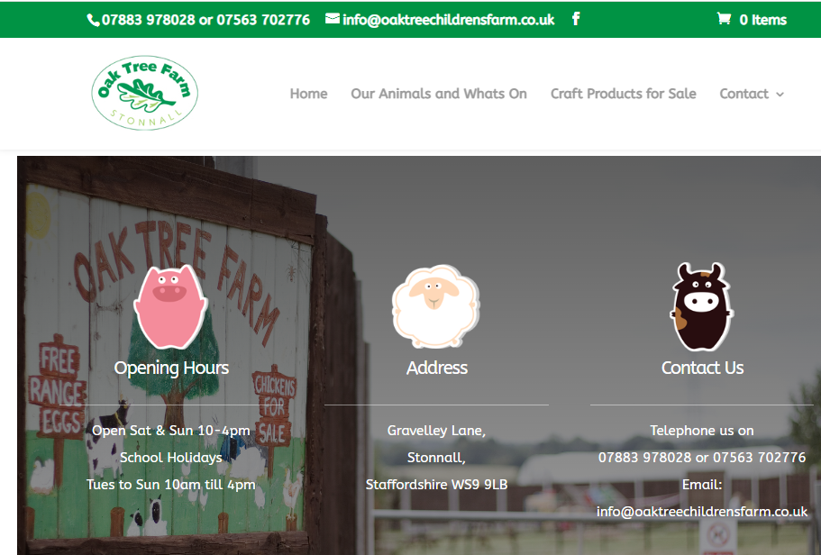

**Welcome to Oak Tree Children’s Farm**

**No booking required. £1 Admission per person. £3 per feed bucket.**

Set in over 18 acres of unspoilt rolling Staffordshire countryside it is the home to lots of animals of all kinds – cows, sheep, pigs, donkeys, geese, ducks, guinea pigs, rabbits, goats, ferrets, poultry and many rare breeds of chickens all are tame and friendly. You will be able to get up close and have lots of interaction feeding the animals.

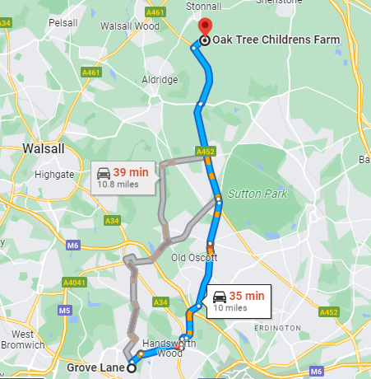Please bring a photo of you at the farm to school if you go!