

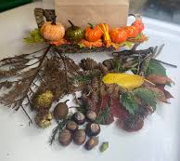

Nursery Holiday Project
During the half term go on an autumn hunt with your family to the park. Collect some autumn treasures.
We are looking forward to see which autumn treasures you will bring back to school to share with your teachers and friends.

Bring your homework back on the W.C. 03/11/25
Nursery Holiday Project
During the half term go on an autumn hunt with your family to the park. Collect some autumn treasures.
We are looking forward to see which autumn treasures you will bring back to school to share with your teachers and friends.

Bring your homework back on the W.C. 03/11/25

