Early Careers Teachers
Information for Applicants


Dawson Road, Handsworth, Birmingham, B21 9HB
Tel: 0121 464 4669

Contents Page

- Copy of advert and return details for application form
- School details
- Job description
- Person specification

BIRMINGHAM CITY COUNCIL DIRECTORATE OF CHILDREN, YOUNG PEOPLE AND FAMILIES

BIRMINGHAM CITY COUNCIL IS COMMITTED TO EQUAL OPPORTUNITIES IN EMPLOYMENT AND WE POSITIVELY WELCOME YOUR APPLICATION IRRESPECTIVE OF YOUR GENDER, RACE, DISABILITY, COLOUR, ETHNIC OR NATIONAL ORIGIN, NATIONALITY, SEXUALITY, MARITAL STATUS, RESPONSIBILITY FOR DEPENDANTS, RELIGION, TRADE UNION ACTIVITY AND AGE

Applications are invited for appointment to the post of

Early Careers Teacher
at
GROVE SCHOOL

Dawson Road, Handsworth, Birmingham B21 9HB

Tel: 0121 464 4669

Head Teacher Ms Justine Baker
Main scale, permanent posts
Starting salary: £31,650

The school was inspected in October 2023. Grove continues to be a good school. Grove School is a 3 form-entry mixed primary school for pupils aged 3 - 11 years, which currently has 678 pupils on roll. It is a multicultural school in an area of high deprivation. Our parents, staff and governors are ambitious for our pupils. The school community works to help every pupil achieve their very best. On entering Grove, you will feel the warmth and pride that we all have in our school.

The senior leadership are looking to appoint enthusiastic ECTs who are willing to grow and develop.

The successful candidates will be expected to take up the appointment at the beginning of the Autumn Term 2025.

We encourage all interested applicants to contact the school to arrange an informal visit, which will be held on:
Friday 31st January 2025 at 10.00am, 2:00pm or 4.00pm Please contact pardeep.kaur@grove.bham.sch.uk to arrange an informal visit.
You will be able to meet with senior leaders, ECTs and pupils during your informal visit.

Closing date: Wednesday 5th February 2025 at 12.00pm.

Interview dates: Wednesday 12th February 2025 and Thursday 13th February 2025.
Completed application forms should be returned to: vacancy@grove.bham.sch.uk

Grove School is committed to safeguarding and promoting the welfare of children and young people and expects all staff to share this commitment. Successful applicants will need to provide evidence of the right to work in the United Kingdom. An enhanced DBS check is required for all successful applicants.

An online search will also be carried out as part of our due diligence on all short-listed candidates.

ABOUT OUR SCHOOL

Type of school: Community
Age range: 3 - 11 years
Percentage of pupils
with English as an additional language: 71%
with SEND: 22%

Grove is an inner-city primary school located in Handsworth.
Children enjoy coming to school to work, play and achieve in a safe and welcoming environment; it is an exciting place to learn.
Ofsted 2023:
This is a happy school. Pupils arrive with smiles on their faces, and they are greeted with a smile in return. The immaculately well-kept school buildings and stunning grounds provide an ‘oasis in the city’. Pupils feel exceptionally safe and well cared for in school because they are. The kindness that everyone shows to each other is evident in all aspects of school life. Pupils say ‘everyone is kind with their actions and words.’
Our inquiry-based curriculum uses Handsworth and Birmingham as focal points to recognise and celebrate our cultural and religious diversity. We believe the education of every child must provide not only knowledge but also skills; our aim is to develop character, critical thinking and leadership skills in every child. We aim to find out and nurture the talent of each as they journey through our school.
Ofsted 2023:
The school has many approaches to developing responsible citizens of today and the future. Pupils learn not to discriminate against others, such as by race, religion, or gender. They have a deep understanding of tolerance and respect. They say, ‘All pupils and teachers respect each other here.’ Pupils benefit from the many opportunities to be young leaders, including being school councillors, attendance ambassadors, digital leaders or peer mediators.
Our work with parents and carers is vital to ensure every child learns and achieves. We value the contributions parents make in helping us understand their child and offer many opportunities for parents to engage in the life of the school. We provide parents and carers with regular information about the progress their child is making.

Ofsted 2023:
The school’s approach to how they work with parents and carers is a strength. Parents are overwhelmingly positive about the school. They recognise the quality of education, care and support the school provides.
Strong values underpin the work of the school: children talk confidently about the Grove Expectations and how they meet these in their daily lives.
Ofsted 2023:
Pupils behave sensibly at all times of the day. As pupils say, ‘there are reminders everywhere’. They listen carefully to their teachers and follow the well-established school rules consistently. Pupils relish learning new things. They can focus well during lessons because they are not disrupted from doing so by others.

ACCOMMODATION

Grove School was built in 1903 and is a three–form entry split site school; both sites are situated on Dawson Road. The main school building, known as the lower school, consist of EYFS, key stage 1 and lower key stage 2; while 500 yards away from the main school is the upper school building, which was built in the 1970s and contains pupils in upper key stage 2.

In lower school we have a school library, two dining halls, two school halls and a reading room. Our school looks small from the outside but when you visit you find we have four outdoor learning areas which contain climbing apparatus, mud kitchens, vegetable patches, an amphitheatre, a cabin, two Forest School areas (one with a pond), a sports arena, water play, a gym and even a beach! Play and lunchtimes are fun at our school.

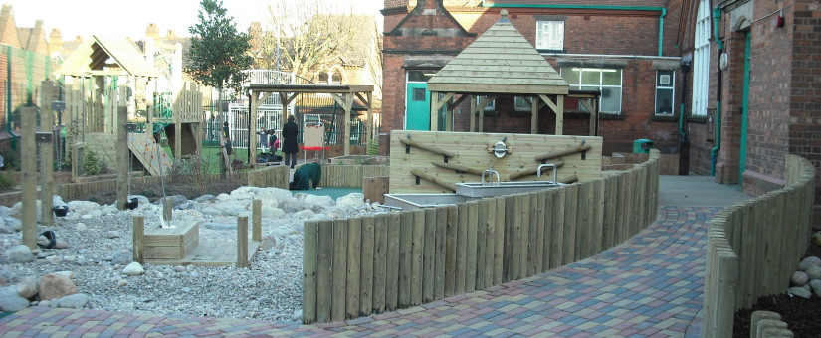

Our upper school building was designed as an open plan build and over the years, we have modernised it to improve the learning spaces: we have added glass doors, lifted ceilings and incorporated reading areas. In upper school we have a school hall and a food technology room.

Another major investment made by the school is a sports hall, which can be found on the lower school site. It has a reading room located on a first floor.

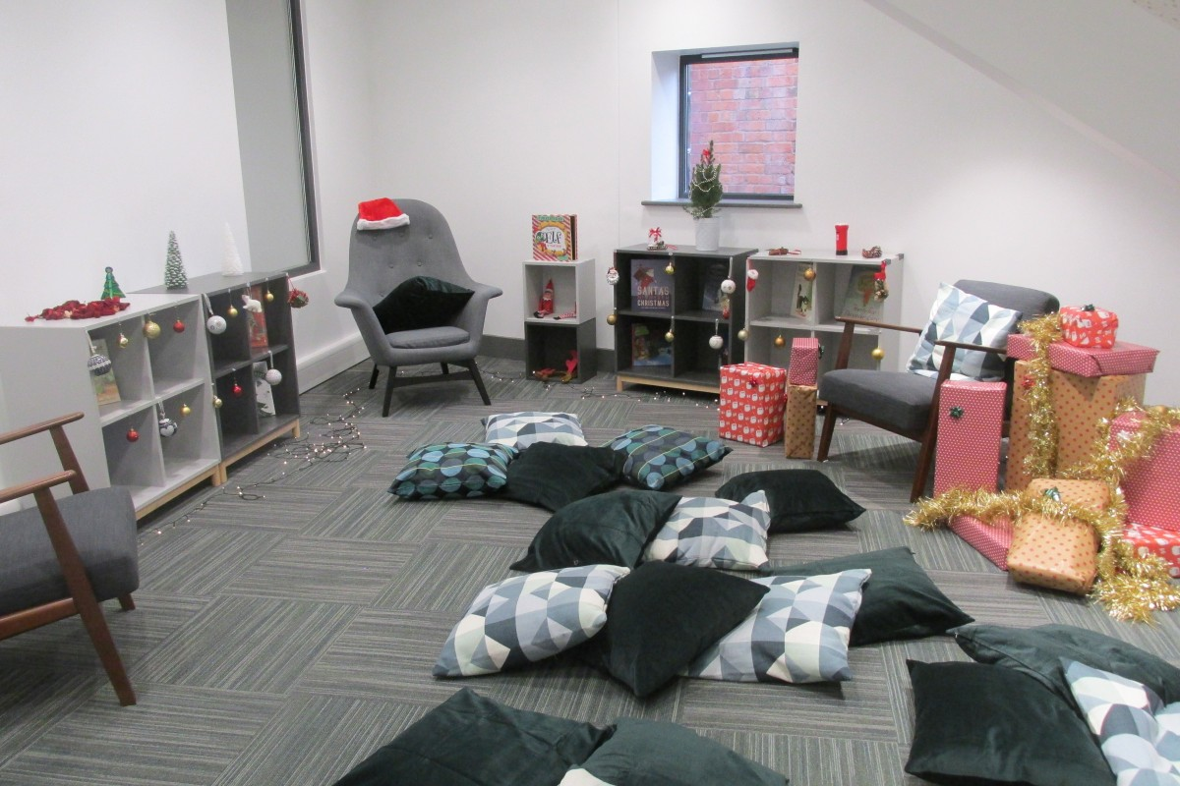

ORGANISATION AND CURRICULUM

Grove school is organised into phases: Early Years Foundation, Key Stage 1, Lower Key Stage 2 and Upper Key Stage 2. Each phase is led by an Assistant Head Teacher.

Early Years Foundation Stage
In our foundation stage, we have part time (two and a half days a week) and full-time pupils attending nursery. We offer morning and afternoon places. Full time places are awarded following the criteria set by the local authority. The nursery children are organised into three nursery groups with a key leader leading play and learning for each group. Rising 3 children join in the spring and summer terms in Nursery. In reception, our 90 pupils are organised into three classes. At Grove, we believe that every child deserves the best possible start in life; a child’s experience in their early years has a major impact on their future life chances. Our foundation stage creates a secure, safe and happy place for children to make the most of their abilities and talents.

Key Stage 1
In key stage 1, our year 1 and 2 children have the opportunity to build on the skills, knowledge and understanding they have developed in the early years. They extend their early reading, writing and maths skills through a vibrant curricular programme. They explore forces and materials in everyday life and find out about houses and homes and toys in the past. They visit the seaside and the zoo, and use their outdoor learning area to investigate, role play and develop leadership skills.

Lower Key Stage Two
Years 3 and 4 embark on their key stage two curriculum studies in core subjects and apply their reading, writing, mathematics and problem-solving skills through their studies of life in Ancient Greece and Rome, Early Islamic Civilisations, and science projects such as: rocks and fossils, magnets and electricity. The local area supports these studies with children making visits to a Gurdwara in Handsworth and Birmingham Museum and Art Gallery. Year 3 and Year 4 swim at the local leisure centres. The children run a school council and build on leadership skills through our citizenship project.

Upper Key Stage 2
Our year 5 and 6 children are educated in the upper school building.
As pupils move through upper key stage 2, they continue to develop their thinking and enquiry skills across the curriculum. Local studies continue to be a focus: the children enjoy learning about the History of the Jewellery Quarter in Year 5 and Matthew Bolton and James Watt in Year 6. Investigation is also at the heart of exciting science topics, such as our study of electricity and materials and their properties; geography topics such as our study of natural disasters; and our design and technology curriculum including making a small bird hide and a fairground ride. The children in upper key stage 2 have the exciting opportunity to attend a residential trip to Whitemoor Lakes in Year 5 and London in Year 6.

In key stage 2 we work with a wide range of specialist teachers to enhance our curricular programmes. Specialists include a drama teacher, music teachers, sports specialists and a computing teacher.

Children continue with their citizenship leadership roles and school council: they have a strong pupil voice and have been instrumental in improving learning and experiences.

Technology is at the heart of education at Grove; pupils have access to a high-quality curriculum with a wide range of technology resources in each class.

PASTORAL CARE AND BEHAVIOUR

Grove School Expectations
It is the expectation that all adults working at Grove and all visitors to Grove, including parents, are aware of and understand how to reward children for following our expectations.
In every classroom and the main school areas there are copies of the Grove Expectations.
Children, parents and staff evolved our “Grove Expectations” in 1995. They have been reviewed regularly with staff, pupils and governors and have not changed over time.

As pupils, staff, parents and visitors:
- We treat others as we would like to be treated
- We are kind and don’t hurt others or their feelings
- We respect all property
- We always try to do our best
- We are honest and tell the truth
- We are good listeners and thoughtful speakers.

If you were appointed to teach at Grove School you would join a team of staff dedicated to achieving the very best for every pupil.

Ofsted 2023:

All staff are committed and proud members of the Grove family. This joined-up approach helps the school to be the happy, successful and warm place it is.

Please visit our school website: www.grove.bham.sch.uk

We look forward to welcoming you on an informal visit.

Justine Baker

Head Teacher



Class teacher Job Description

Teachers’ Standards

At Grove teachers make the education of their pupils their first concern, and are accountable for achieving the highest possible standards in work and conduct. Teachers act with honest and integrity; have strong subject knowledge, keep their knowledge and skills as teachers up to date and are self critical; forge positive professional relationships; and work with parents in the best interests of their pupils.

  - The post calls for an experienced class teacher with a lively, enthusiastic approach to teaching, who will enjoy working in a liberal environment with a multi-cultural community of children and will develop and deliver an appropriate curriculum to meet their needs.

  - Commitment to the school and the community is essential. This will involve positive support of the school and children inside and outside school hours.

  - A high standard of class teaching will be expected. This will include:
- set high expectations which inspire, motivate and challenge pupils;
- promote good progress and outcomes by pupils;
- high quality of planning, delivery and marking of work;
- teach well structure lessons which promote a love of learning and children’s intellectual curiosity;
- adapt teaching to respond to the strengths and needs of all pupils;
- deploy support staff effectively;
- make accurate and productive use of assessment, recording and reporting on pupil attainment;
- manage behaviour effectively to ensure a good safe learning environment;
- communicate effectively with parents with regard to pupils’ achievements and well-being;
- reviewing and auditing own performance, take responsibility for improving teaching through appropriate professional development, responding to advice and feedback from colleagues;
- high quality display of children’s work inside and outside the classroom;
- maintain excellent pastoral care of pupils.

  - A preparedness to contribute to the wider life and ethos of the school, to be involved with other staff in school residential visits will be essential.

  - All teachers are encouraged to involve themselves in supporting children out of school hours. This is seen as an important optional way of helping develop the whole school community.

  - Leadership qualities and initiative will be encouraged in working with staff and children.

  - A high standard of professionalism will be required, to demonstrate consistently high standards of personal and professional conduct.

  - To work and co-operate as part of a team, to agreed objectives, develop effective professional relationships with colleagues, knowing how and when to draw on advice and specialist support.

  - Commitment to the implementation of school policies and routines is essential.

  - Preparedness to support staff in positive and constructive ways will be essential.

  - There may be, from time to time, additional duties as required by the Head teacher (by negotiation with Head and Governors, if necessary at any time in the future).

To fulfil the Teachers’ Standards

https://www.education.gov.uk/publications/eOrderingDownload/teachers%20standards.pdf

Professional Duties of Teachers

3.1 Teachers are required to meet the professional duties of teachers as set out in the statutory School Teachers’ Pay and Conditions Document.

Specific

  - All teachers at Grove are expected to work mutually in helping manage the school – supporting colleagues with discipline, day-to-day administration, where appropriate, observing, analysing and participating in school life.

I understand that all school policies in the staff are available on the school intranet and it is my responsibility to familiarise myself with these policies.

Signed: ……………………………………… Postholder…………………………………….Print name

…………………………………………Head teacher

……………………………………… Date

Teacher Person Specification PERSON SPECIFICATION: Teacher

 | ESSENTIAL | METHOD OF ASSESSMENT
 |  | AF | L | O | I | R
Qualifications | A good degree in a related subject, or equivalent | ✓
 | Qualified Teacher Status, or be eligible for Qualified Teacher Status through an appropriate route. | ✓
 | Have passed the professional skills test in numeracy, literacy. | ✓
Professional Knowledge and Understanding | At an appropriate level:
 | Have a knowledge and understanding of a range of teaching, learning and behaviour management strategies and know how to use and adapt them. | ✓ | ✓ | ✓ | ✓ | ✓
 | Know and understand how to personalise learning and provide opportunities for all learners to achieve their potential. | ✓ | ✓ | ✓ | ✓ | ✓
 | Know the assessment requirements for the primary school key stages. | ✓ | ✓ |  | ✓ | ✓
 | Have a secure knowledge and understanding of the curriculum areas and related pedagogy to enable effective teaching across the age and ability range. | ✓ | ✓ | ✓ | ✓ | ✓
 | Know how to use local and national statistical information to evaluate the effectiveness of their teaching, to monitor progress and raise attainment. | ✓ | ✓ |  | ✓ | ✓
 | Know the legal requirements, national and local policies and guidance on the safeguarding and promotion of the well-being of young people. | ✓ | ✓ |  | ✓ | ✓
 | Demonstrate awareness and understanding of the implication of equality, inclusion and multi-cultural education. | ✓ | ✓ | ✓ | ✓ | ✓
 | Understand how students with special educational needs may be integrated in to the classroom. | ✓ | ✓ | ✓ | ✓ | ✓
 | ESSENTIAL | AF | L | O | I | R
Professional Skills | At an appropriate level:
 | Able to plan for progression across the age and ability range, designing effective learning sequences, demonstrating secure subject/curriculum knowledge. | ✓ | ✓ | ✓ | ✓ | ✓
 | Able to use a range of teaching and learning strategies and resources, including e-learning | ✓ | ✓ | ✓ | ✓ | ✓
 | A confident and competent user of ICT. | ✓ | ✓ | ✓
 | Able to make effective use of a range of assessment, monitoring and recording strategies to assess learning needs and set challenging learning objectives and raise standards. | ✓ | ✓ |  | ✓
 | Able to provide timely, accurate and constructive feedback on attainment, progress and areas for development | ✓ | ✓ |  | ✓ | ✓
 | Demonstrate the ability to work independently and collaboratively as a member of a team, sharing and developing effective practice. |  | ✓ | ✓ | ✓ | ✓
Professional Attributes | At an appropriate level:
 | Be aware of the professional duties of teachers and the statutory framework within which they work. | ✓ | ✓ |  | ✓
 | Have high expectations of students including a commitment to ensuring that they can achieve their full potential and to establishing fair, respectful, trusting, supportive, and constructive relationships with them. | ✓ | ✓ | ✓ | ✓ | ✓
 | Be aware of the policies and practices of the school and share in the collective responsibility for their implementation. | ✓ | ✓ |  | ✓
 | Able to communicate effectively, both orally and in writing with pupils, colleagues, parents, carers, Governors, external agencies. | ✓ | ✓ | ✓ | ✓
 | Have a commitment to collaboration and co-operative working. | ✓ | ✓ |  | ✓ | ✓
 | Demonstrate positive values, attitudes and behaviour and adopt high standards of behaviour in their professional role. | ✓ | ✓ | ✓ | ✓ | ✓
 | Evidence of continuous INSET/training and commitment to continuing and further professional development | ✓ | ✓ |  | ✓ | ✓
 | Demonstrate ability to act upon advice and feedback and be open to coaching and mentoring. | ✓ | ✓ | ✓ | ✓
 | ESSENTIAL | AF | L | O | I | R
Personal Characteristics
 | Be creative in problem solving together with a willingness to take on or try new approaches and ideas. | ✓ | ✓ | ✓ | ✓
 | Demonstrate reliability and integrity. | ✓ | ✓ |  | ✓ | ✓
 | Have good personal organisation. | ✓ | ✓ | ✓ | ✓ | ✓
Contra Indications | Criminal Convictions involving offences against children | ✓ |  |  | ✓ | ✓
AF = Application Form L = Letter O = Observation I = Interview R= Reference

Method of assessment (MoA)
AF = Application Form L = Letter O = Observation I = Interview R= Reference

