Friday 27th May, 2022

Dear parents and carers,

The children have had a fantastic end to this term, they thoroughly enjoyed dressing up and eating their special Platinum Jubilee lunch.

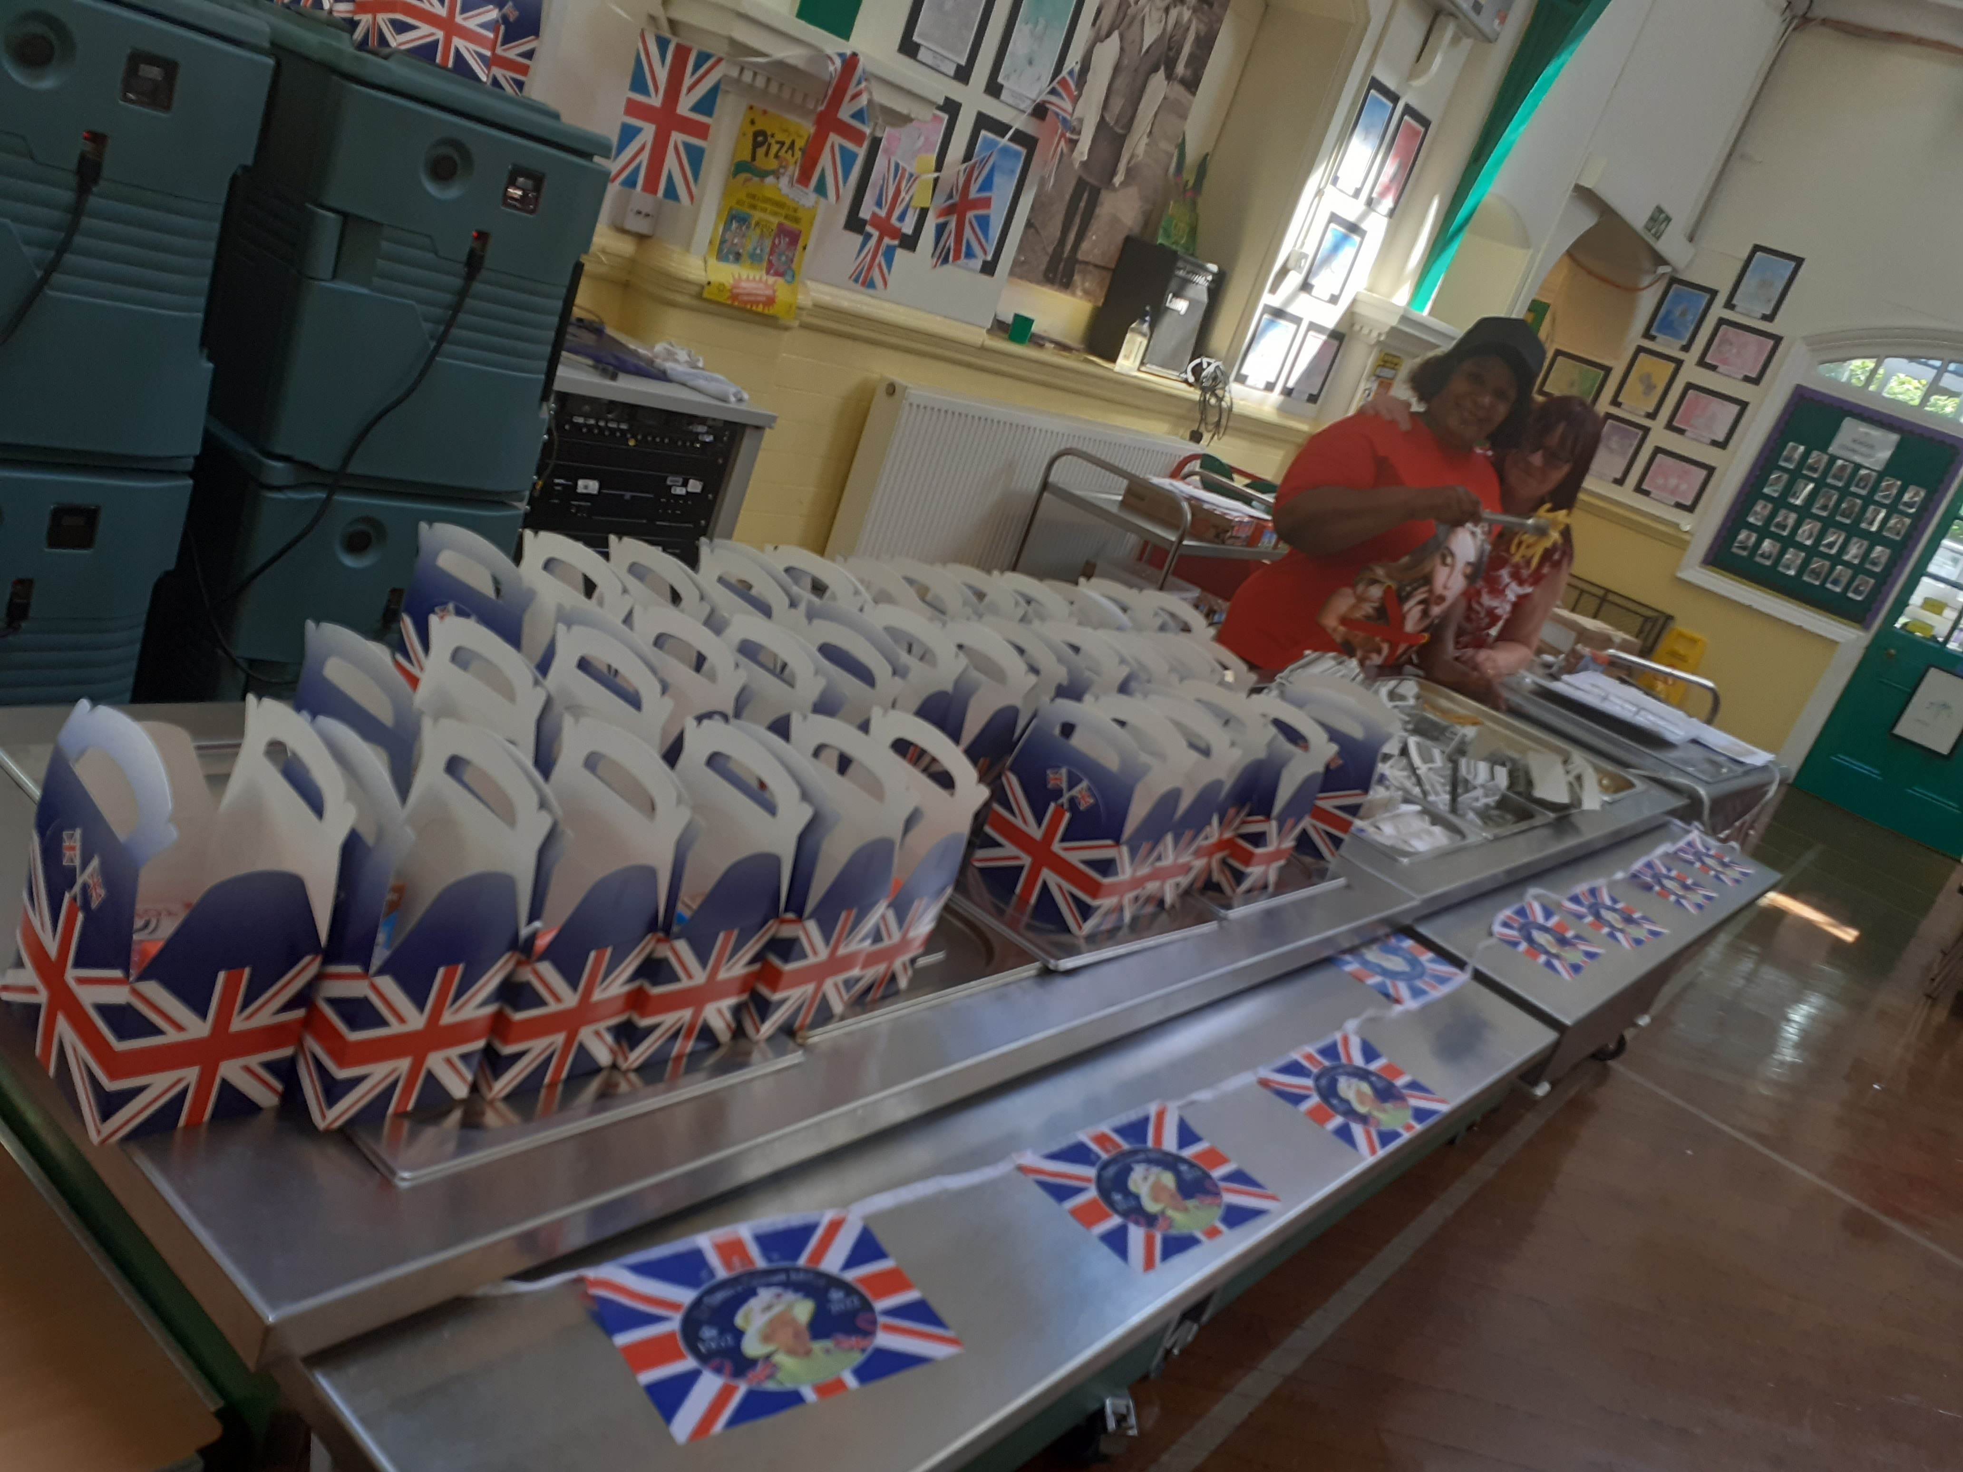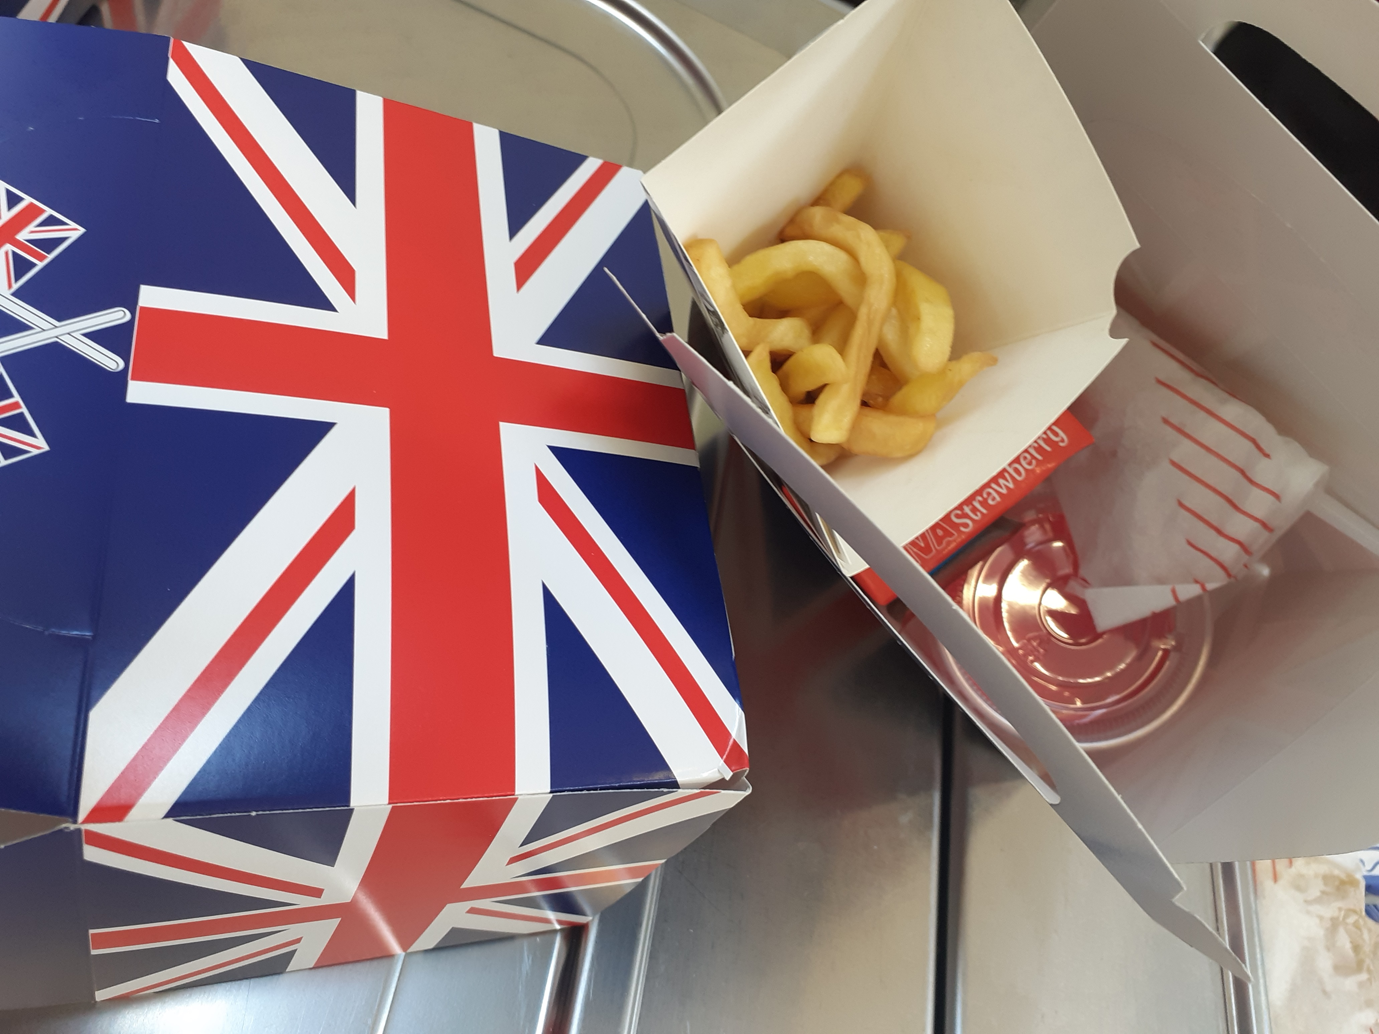

Year 6 London and Harry Potter Experience
Our Year 6 pupils visited The Warner Brothers Harry Potter Experience; they knew so much about the novels and some pupils are really keen to read more of the books. 41 pupils stayed in London, they went on a boat tour on The River Thames, saw the landmarks of London from The London Eye, shared a meal together at Pizza Express, visited The Globe Theatre and found out what it was like to visit the theatre in Shakespearean England and finished their visit by exploring and playing in the Princess Diana Memorial Park. Many members of the public commented on the behaviour of our children, the staff from No Limits were impressed with their knowledge about Shakespeare, The Globe Theatre and the geography of London. Have a look on the school website to see photographs of the visit: http://web.grove.bham.sch.uk/gallery-262-london-residential-may-2022

Year 2 and Year 6 assessments
The pupils in Year 2 and 6 completed their tests this term, they approached this with positivity and enjoyed showing their teachers what they have learnt. We will share how well they have done in their end of year reports.

Punctuality challenge
The 10-day punctuality challenge ran again from Monday 16th May to Friday 27th May. An amazing total of 601 children arrived on time, every day, for 10 days. Each child has been given a small prize and a raffle has held for each year group for a bigger prize. Full details about the challenge including the winners can be found on our website. We look forward to the next challenge!

Term dates
Term starts on Monday 6th June, we look forward to welcoming the children back after their half term holiday.

School finishes for all pupils on Monday 18th July. Tuesday 19th, Wednesday 20th and Thursday 21st July are staff training days.

End of term events
It has been delightful to see parents coming into school to collect children, thank you to all parents who have collected children on time at 3.15pm. School for nursery pupils finishes at 3.30pm.

We have planned end of term award celebrations in July, we will be inviting all parents to this special event in upper school.

As you are aware we will also be saying a huge thank you to Mrs Matty who is retiring from Grove in July. We have planned a garden party event to which all parents will be invited to recognise the amazing contribution Mrs Matty has made to the lives and opportunities of thousands of children. This event will also be an opportunity to thank those staff who left Grove in the previous two years.

I hope you all have a restful and relaxing holiday and look forward to sharing more about events next term with you in June.

Yours sincerely



Ms J Baker
Deputy head teacher

