31st March 2023

Dear Parents and Carers,

At Grove we continue to offer the very best education for your children. As the Spring Term draws to the end I would like to share some of the highlights of this term.

Nursery pupils delighted in watching chicks hatch from eggs, they held chicks and learned how to look after them. The children have started to learn their phonemes using our phonics scheme Little Wandle Letters and Sounds Revised. They are sharing books and talking about what they can see in the pictures. Parents are really supportive and keen for their children to read. To find out more about our phonics scheme go to: https://www.littlewandlelettersandsounds.org.uk/

In Reception, pupils are making amazing progress in learning their phonics sounds and are using them to blend. Thank you to parents for making sure you read at home with the children and return the books to school each day. Pupils have explored snow, taken part in pond dipping and found out more about the school site as they walked around to create their own simple maps. Each Reception class has their own pet goldfish and they are enjoying finding out about fish including how to look after them.

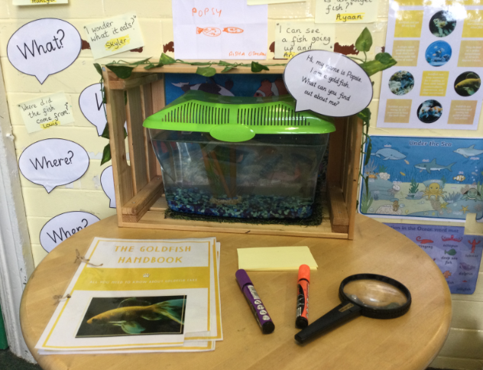

In Year 1, the children are applying their knowledge of phonemes as they blend confidently to read. Parents support reading at home so well and have been positive about the reading workshops we have held in the classrooms this year. The children in Year 1 have enjoyed learning how to print a repeated pattern in art and about the lives of important people in their history lessons. The most exciting event for our Year 1 pupils this term was the arrival of Chip their new pet hamster.

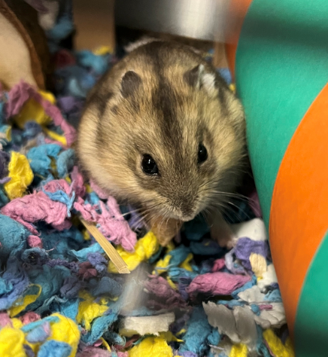

Year 2 pupils spent a day at the Brighouse in Atherstone where they explored the woods and undertook a field study of the area. This taster visit has prepared the children well for Year 4 when they visit and stay overnight. The children in Year 2 have worked really hard to design and make a flower brooch using fabric in their design and technology. They have been looking after their pet stick insects and have learned how to care for the plants in school.

In Years 3 and 4, the pupils have continued to enjoy their weekly swimming lessons. They are becoming more confident in the water. A number of children in Year 3 can now swim 10 meters independently, 68% of the children in Year 4 can now swim 25 meters independently and 22% of the children in Year 4 can now swim 50 meters independently. The science lessons in Year 3 have been a particular highlight. The children have enjoyed learning more about their bodies and know how to keep themselves fit and healthy. In Year 4, the children have enjoyed exploring how yeast acts in food and have finished the term by designing and making their own pizza.

The parental science workshops were well supported by parents in Years 5 and 6. Parents enjoyed helping their children to create models of the heart in Year 5 and periscopes in Year 6. The highlight for Year 5 was the residential visit to Whitemoor Lakes this week. The children have shown great courage, determination, resilience and teamwork skills both in school and on the visit. Have a look at some photographs of the children on their visit on our school website https://web.grove.bham.sch.uk/gallery-264-whitemoor-lakes-2023.

In Year 6, the children are continuing to work hard in reading, writing and maths in preparation for their upcoming SATs tests. The uptake for the upcoming London residential in May has been overwhelming. We can’t wait to take the children to London for 2 days to explore the city.

This term we have run 20 after school clubs, 381 pupils have attended a club and we look forward to more pupils experiencing a club in the summer term.
We ran 2 parental workshops for parents and carers of children with special educational needs at Grove. These workshops provided parents and carers with strategies and resources to use at home to support their children with developing their communication and interaction skills. These sessions were well received by the parents who were invited. All parents commented on how helpful the workshops were and were excited to begin using

the laminated resources with their children at home. There will be whole school SEND workshops after school on Wednesday 19th April 2023 and a toileting workshop in the summer term. Please let Miss Dowell know if you would like to attend this workshop.
Our parents’ workshops for reading, mathematics and science have been very well attended. I know parents value finding out what and how we teach at Grove. These are some of the feedback comments from parents. Parents said they enjoyed:

- Learning with my daughter
- Spending time with my kids while having fun with them
- Helping my child with the activity and listening to his ideas
- Great workshop, I learnt so much!
- Children were given the freedom to experiment with their ideas
We will be offering workshops in reading and phonics, internet safety, SEND and transition to the next year group in the summer term.

Current attendance of pupils is 92%. This is lower than the school target of 95%. We continue to award pupils for good attendance and hope our pupil Attendance Ambassadors will help improve attendance. If your child’s attendance is below 92% we will contact you to talk about what the reasons for low attendance are. We are here to help.

I would like to wish those of you who are celebrating Easter, Eid and Vaisakhi an enjoyable time with your family and friends. Your response to food donations during Ramadan and Comic Relief demonstrates the generosity of our community.

School reopens to pupils on Monday 17th April 2023 at 8.30am.

I would like to inform parents that term ends for the summer break on Friday 21st July. Monday 24th and Tuesday 25th July are staff training days.

Yours sincerely,

Ms J Baker
Head Teacher

