EYFS and Key Stage 1 Science Week Competition
Growing a broad bean plant
Hello everyone!
Are you ready for a challenge?
The Science Week topic this year is Growth, so we’re going to try to grow our own broad bean plant.
How exciting!
Here is your broad bean:
Sellotape broad bean here

Now here are the instructions for you and a grown up to follow to grow the best plant:
Rinse a clean jam jar, leaving it wet inside. Put in a folded piece of kitchen roll and press it up against the glass. Put a broad bean seed between the kitchen roll and the glass and leave on the windowsill. Add a spoonful of water to the seed every day, enough to keep the jar moist but not waterlogged. After a few days, the broad bean should sprout. After a couple of weeks, you'll have your own broad bean seedling, which can be planted out into a 10cm pot of compost or open ground.
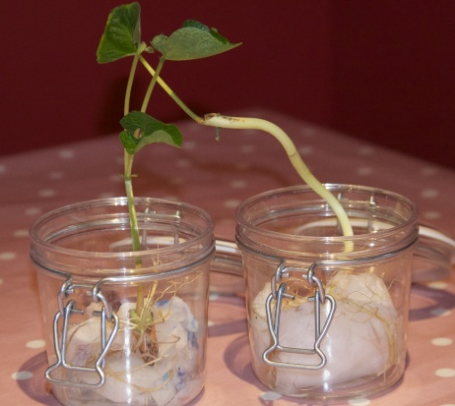
Your teacher would love to see your plants. Bring them into school with you on Monday 4th April so we can see how much they have grown.

