Year 6 Holiday Project May 2022
Next term we will be continuing our study of the world’s most famous playwright, William Shakespeare! This holiday we would like you to familiarise yourself with this inspirational man and his timeless plays.

First, have a look on the Royal Shakespeare Company website, pick a play and start on level 1 to find out more about the plot, characters, language and staging:
https://www.rsc.org.uk/shakespeare-learning-zone
You could also watch one of these short summaries of your chosen play. Be warned, the songs are very catchy!
https://www.bbc.co.uk/teach/class-clips-video/english-ks2--ks3-shakespeare-in-shorts/zjyhrj6

Now that you know a bit more about his plays, we would like you to complete one of the following tasks:
- Pick a play and design a comic strip to summarise the plot.
- Choose a play to act out with your family and video this. Put it on bgfl or email your video to your teacher- we would love to see it!
- Make finger puppets characters for your chosen play and put on a puppet show. Send us photos of your puppets or even video your play for us!

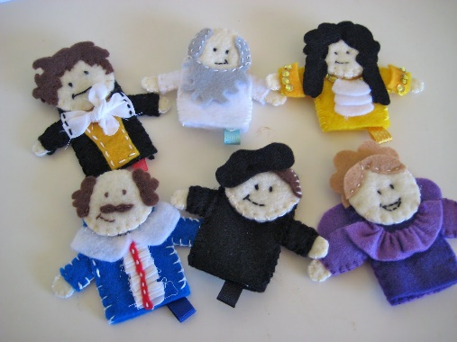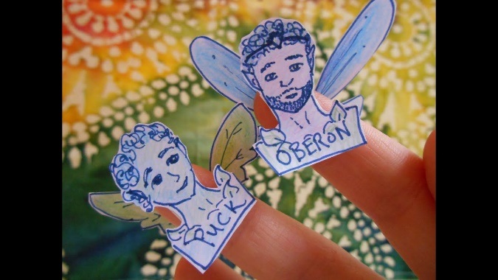

We look forward to seeing your projects when we return to school on Monday 6th June 2022.

