Year 5 Holiday Project
December2021

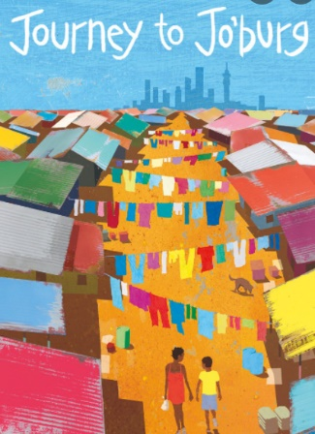
Next half term, our class novel is Journey to Jo’burg which is set in South Africa. For you holiday project, we would like you to research about South Africa. This could be historical events, famous faces, geography and the landscape or anything other interesting facts you can find.

You could create a web page using J2e5 on BGFL, a poster, a booklet or a map. You could place different facts on different parts of your map.

Please complete your holiday project by Tuesday 4th January 2022 and upload your work to BGFL or return it to your class teacher.

