Year 4 Holiday Project May 2022

Next term, we will be learning about ‘The Town’ in Spanish.
Over the holiday we would like you to research a town in Spain, finding out about where this town is located on the map (north, east, south, west), the weather, population, landmarks, famous events and people from this town. Think of a fun and creative way to present your research. This could be a poster, a leaflet or a presentation.

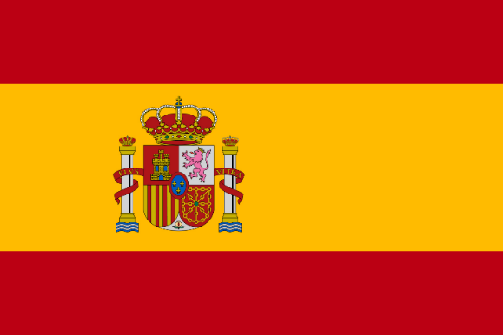
We look forward to seeing your holiday projects!
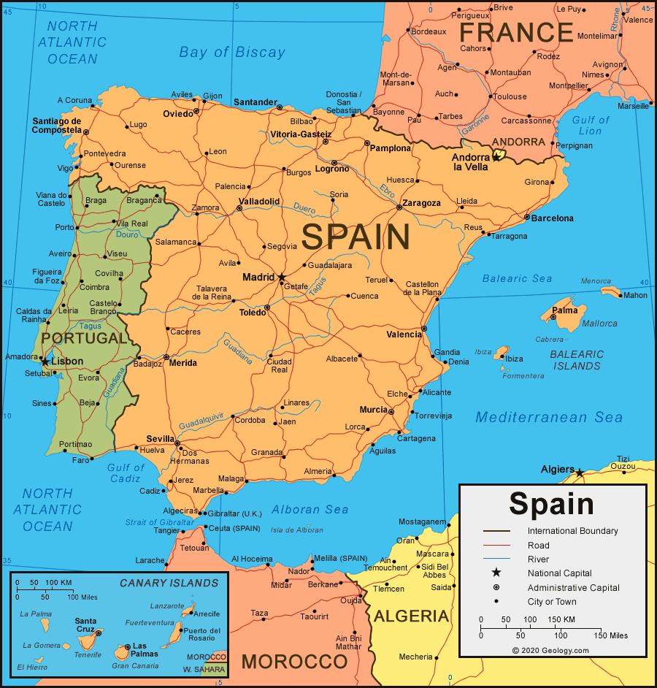

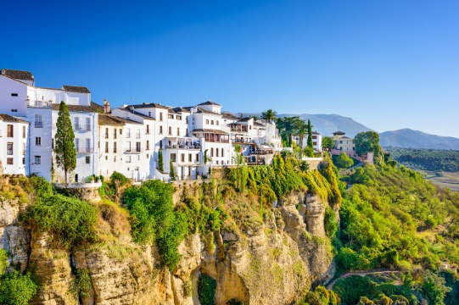

Please return your holiday project to your teacher on Monday 6th June 2022

