**Year 2**

**Holiday Project**

**December 2017**

Next half term we will be exploring the history of our local area.

Our topic will be all about Matthew Boulton, who is an important person that lived in our local area, and James Watt.

As part of our topic we will visit two important places in our local area: Soho House and Handsworth Park.

Over the Christmas holidays, we would like you to **sketch** a picture of somewhere in your local area that is important to you.

[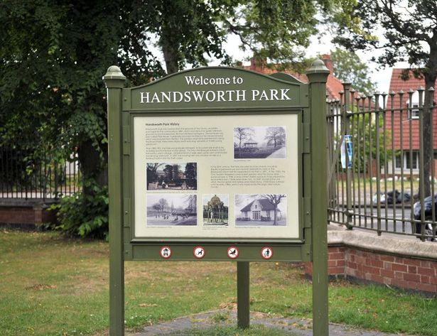](http://www.google.co.uk/url?sa=i&rct=j&q=&esrc=s&source=images&cd=&cad=rja&uact=8&ved=0ahUKEwj5nqSu8-bQAhVF0xQKHZwaABYQjRwIBw&url=http://www.birminghammail.co.uk/news/local-news/handsworth-park-fish-death-caused-5377936&bvm=bv.141320020,d.ZGg&psig=AFQjCNFe2P9NscLnJyqRYQCWgJqxzSNnZA&ust=1481365642802072)[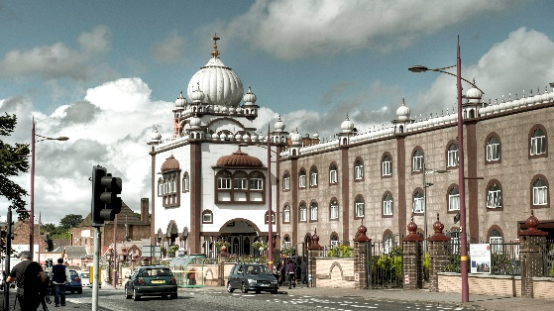](http://www.google.co.uk/url?sa=i&rct=j&q=&esrc=s&source=images&cd=&cad=rja&uact=8&ved=0ahUKEwiB0-Gz8ubQAhXBXhQKHQnMDBUQjRwIBw&url=http://handsonhandsworth.info/tag/soho-house/&bvm=bv.141320020,d.ZGg&psig=AFQjCNFsMYd1IDGJqt5akFa41j27kZyrSQ&ust=1481365393385757)

[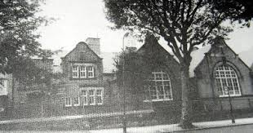](http://www.google.co.uk/url?sa=i&rct=j&q=&esrc=s&source=images&cd=&cad=rja&uact=8&ved=0ahUKEwiSz96C8-bQAhWHUBQKHVepDxQQjRwIBw&url=http://www.birminghamforum.co.uk/index.php?topic%3D2081.0&bvm=bv.141320020,d.ZGg&psig=AFQjCNEePhVLp6bLlgMClxZ7yXc5BJZcOw&ust=1481365551705676)Please bring your sketches back to school on Tuesday 9th January 2018.