Year 2 Holiday Project
May 2022

Our topic for the next half term is ‘Oh we do like to be beside the seaside!’

It’s a very exciting topic all about the seaside, and will end with our big trip to Weston Super Mare at the end of term.

For this holiday project you have a choice of tasks. You can:

- Research Weston Super Mare and make a poster or fact file,
- Design an outfit that would be suitable for a sunny day at the beach (think carefully about what you would need to take with you),
- Design and write a postcard to one of your friends or teachers about your holiday,
- Write a set of instructions for a game you could play on the beach.
You don’t need to do all of them, just pick your favourite. Be creative and enjoy!
lease return your holiday project to your teacher on Monday 6th June2022e return your holiday project to your teacher on Monday 6th June2022

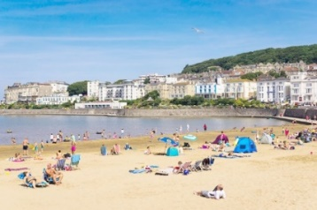
Please return your holiday project to your teacher on Monday 6th June2022.

