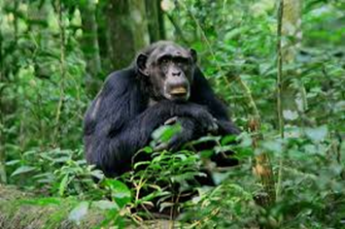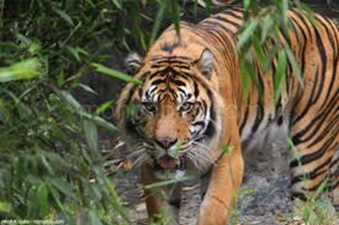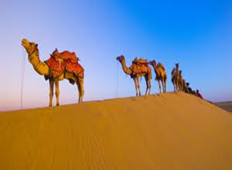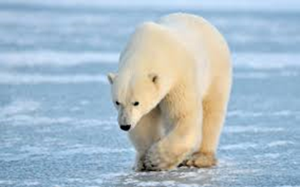

**Year 1**

**Year 1 Holiday Project May 2022**

Next half term we will be exploring different habitats. Your task is to design

a poster or fact file for an animal that lives in either the desert,

the rainforest, the jungle or the arctic.

We will put the best examples of your work on display so make sure your

handwriting is neat and you present your work with care.

Please return to school on Monday 6th June 2022

We look forward to seeing your habitats on:

**Monday 6th June 2015**

**Please return your work to school on Monday 2nd June 2014**