Year 4 Holiday Project
December 2021
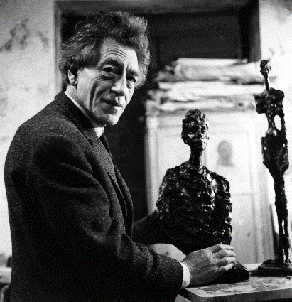

Alberto Giacometti
Next half term, we will be looking at the artist, Alberto Giacometti. We will be learning all about who he was, what his artistic style was and we will be creating art in the style of his work.

You have the choice of these activities:
- Create a piece of art in the style of Giacometti’s work.
- Create a fact-file on Alberto Giacometti thinking about who he was, where he came from and how he became an artist.
- Create a poster all about Alberto Giacometti and his artworks.

Please return your holiday project to your teacher on Tuesday 4th January 2022

