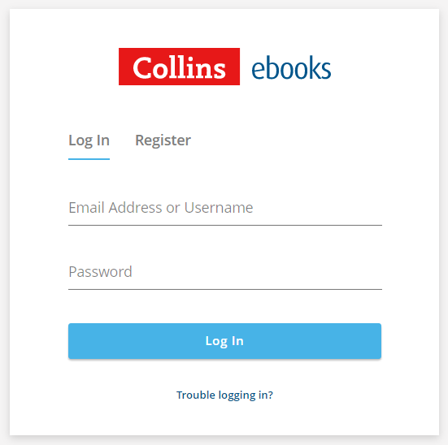
Collins Big Cat ebook libraries
Parent Guide

Logging in
To access your child’s Big Cat ebooks, go to: https://ebooks.collinsopenpage.com/ (see right).
Enter the username and password provided by your school to access your library.
If you misplace your password, contact your school.

Library
Once logged in, you will land on the library. Here you will see any books that have been assigned to your child by their teacher. You can access a resource sheet for each book by clicking the three dots, then “Resources”, as shown below.
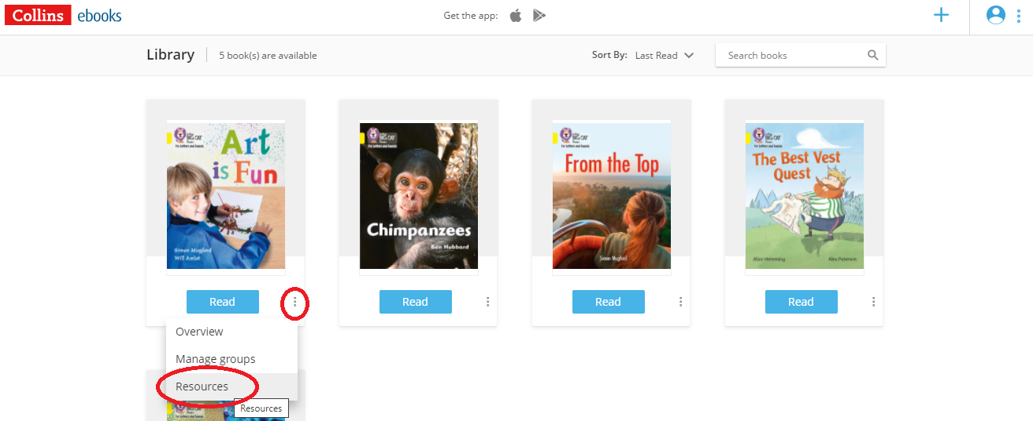

The reader
To open one of the books, select either the cover or the “Read” button. You will see this screen.
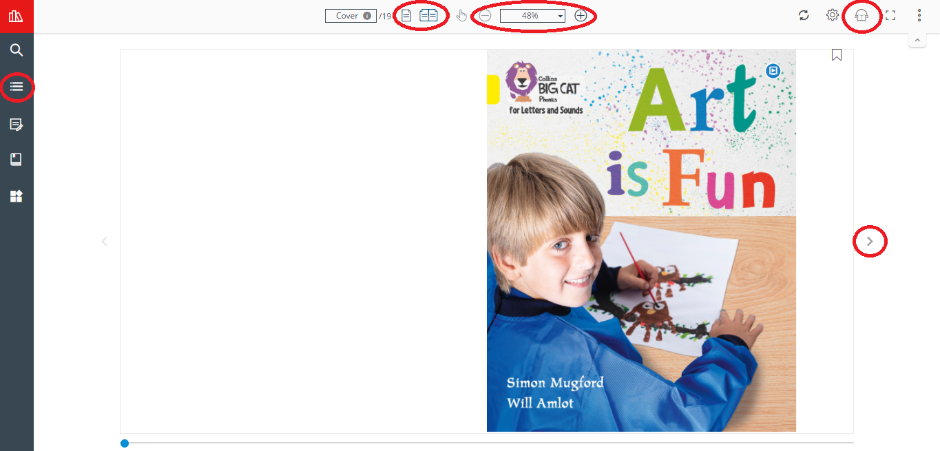
Some key elements of the reader are highlighted in the above image:
- Use the arrows either side of the page to leaf through the book.
- Use the single and double page icons to switch between those two views. Many of the Big Cat books are best experienced using the double page view.
- Use the zoom function as required. The “Fit to width” option helps you to make best use of your screen
- For longer books, you can use the Table of Contents in the left hand menu to navigate.
- Don’t worry about remembering where you left off. When you next open the book, you will start from where you left off.

Audio
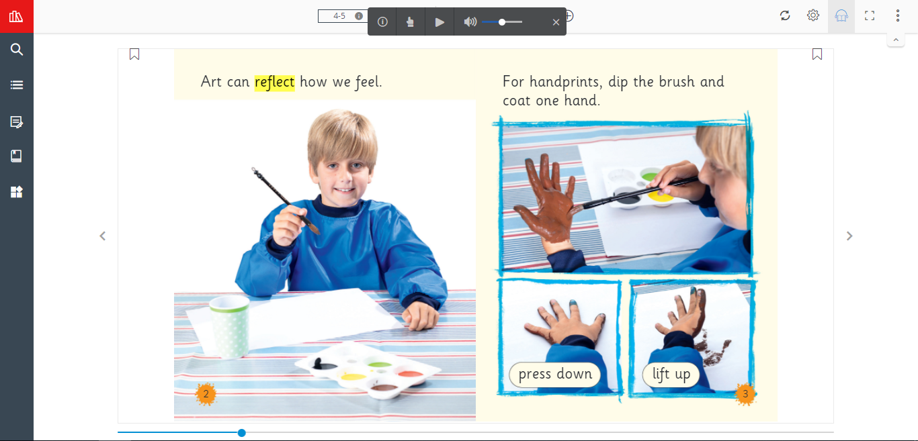
Where audio is available, the audio icon will appear in the top right corner. Click this to launch the audio toolbar (shown below).
The words will be highlighted as the audio plays. You can pause the audio at any time, and adjust the volume. The finger icon in the toolbar allows you to point at any word, and the audio will begin playing from there. To dismiss the audio toolbar, simply click the cross icon.

Apps
The Collins eBooks app is available for iOS from the App Store and for android devices on the Google Play Store. The app is free to download, and you can log in using the same details.
When using the app, you can download books to your device, after which you can then access them without needing to be connected to the internet.

