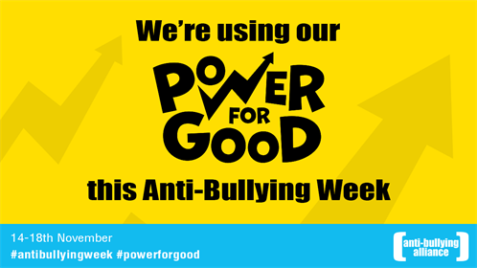

At Grove we are looking forward to our whole school focus on anti-bullying next week,
14 – 18 November 2016
Anti-bullying week
The Power of Friendship
Nursery and Reception classes will be exploring what makes a good friend. They will also be working as spies to spot children who are being good friends.
The Power of Kindness
Years 1 and 2 will be doing some role play, poetry and appointing a secret kindness detective to detect kind acts.
The Power of Language
Years 3 and 4 are exploring words and language that can be negative and positive. They will also be learning about online cyberbullying.
The Power of Differences
Years 5 and 6 are exploring and celebrating differences between people. They will be focussing on how people can be bullied if they do not conform to the ‘norm’.
There is lots of information on anti-bullying week at:
http://www.anti-bullyingalliance.org.uk/anti-bullying-week/

Children in Need
We will be raising money for Children in Need.
Children are invited to dress in something spotty or blue next Friday, 18th November.
